***REQUEST FOR PROPOSAL DOCUMENT***

***FOR THE BEAUTIFICATION OF PALTAN BAZAR ROAD ON PPP BASIS.***

***(FROM CLOCK TOWER JUNCTION TO LAKHI BAGH POLICE STATION T JUNCTION)***

***PPP Mode: - Design Finance Built Operate Maintain and Transfer basis for the period of 20 years against the right for display advertisement.***



***NAGAR NIGAM DEHRADUN***

***(Municipal Corporation Dehradun)***

***1 Patel Road***

***Phone No- 0135 – 2655620, 2653572***

***Fax No- 0315-2651060***

***E-mail –*** [***nagar_nigm2008@yahoo.com***](mailto:nagar_nigm2008@yahoo.com)

***Website – nagarnigamdehradun.com***

***Uttarakhand***

***2014-2015***

***Cost of the Document ____________INR***

*DISCLAIMER*

*The information contained in this Request for Proposal (RFP) document or subsequently provided to Bidder(s), whether verbally or in documentary or any other form by or on behalf of Nagar Nigam Dehradun or any of their employees or advisors, is provided to Bidder(s) on the terms and conditions set out in this RFP and such other terms and conditions subject to which such information is provided.*

*This RFP is not an agreement and is neither an offer nor invitation by NAGAR NIGAM DEHRADUN to the Perspective Bidders or any other person. The purpose of this RFP is to provide the Bidders with information that may be useful to them in preparing and submitting their proposal pursuant to the Bidding Documents including this RFP (the "Bid"). This RFP includes statement, which reflect various assumptions and assessments arrived at by NAGAR NIGAM DEHRADUN in relation to the Project. Such assumptions, assessments and statements do not purport to contain all the information that each Bidder may require. This RFP may not be appropriate for all persons, and it is not possible for NAGAR NIGAM DEHRADUN, its employees or advisors to consider the investment objectives, financial situation and particular needs of each party who reads or uses this RFP. The information provided in the RFP is on assumption basis & may not be totally complete. Each Bidder should, therefore, conduct its own investigations and analysis and should check the accuracy, adequacy, correctness, reliability and completeness of the assumptions, assessments, statements and information contained in this RFP and obtain independent advice from appropriate sources.*

*Information provided in this RFP to the Bidder(s) is on a wide range of matters, some of which depends upon interpretation of law. The information given is not intended to be an exhaustive account of statutory requirements and should not be regarded as a complete or authoritative statement of law. NAGAR NIGAM DEHRADUN accepts no responsibility for the accuracy or otherwise for any interpretation or opinion on law expressed herein.*

*NAGAR NIGAM DEHRADUN, its employees and advisors make no representation or warranty and shall have no liability to any person, including any Bidder under any law, statute, rules or regulations or tort, principles of restitution or unjust enrichment or otherwise for any loss, damages, cost or expense which may arise from or be incurred or suffered on account of anything contained in this RFP or otherwise, including the accuracy, adequacy, correctness, completeness or reliability of the RFP and any assessment, assumption, statement or information contained therein or deemed to form part of this RFP or arising in any way by participating in this Bidding Process.*

*NAGAR NIGAM DEHRADUN also accepts no liability of any nature whether resulting from negligence or otherwise howsoever caused arising from reliance of any Bidder upon the statements contained in this RFP.*

*NAGAR NIGAM DEHRADUN may in its absolute discretion, but without being under any obligation to do so, update, amend or supplement the information, assessment or assumptions contained in this RFP.*

*The issue of this RFP does not imply that NAGAR NIGAM DEHRADUN is bound to select a Bidder or to appoint the Successful Bidder or Concessionaire, as the case may be, for the Project and NAGAR NIGAM DEHRADUN reserves the right to reject all or any of the Bidders or Bids without assigning any reason whatsoever.*

*The Bidder shall bear all its costs associated with or relating to the preparation and submission of its Bid including but not limited to preparation, copying, postage, delivery fees, expenses associated with any demonstrations or presentations which may be required by NAGAR NIGAM DEHRADUN or any other costs incurred in connection with or relating to its Bid. All such costs and expenses will remain with the Bidder and NAGAR NIGAM DEHRADUN shall not be liable in any manner whatsoever for the same or for any other costs or other expenses incurred by a Bidder in preparation or submission of the Bid, regardless of the conduct or outcome of the Bidding Process.*

*SECTION 1: PROJECT BACKGROUND*

*Dehradun is the capital city of the state of Uttarakhand in the northern part of India. Located in the Garhwal region, it is 236 km north of India's capital New Delhi and is one of the "Counter Magnets" of the National Capital Region (NCR) being developed as an alternative centre of growth to help ease the migration and population explosion in the Delhi metropolitan area. Dehradun is in the Doon Valley on the foothills of the Himalayas nestled between two of India's mightiest rivers — the Ganges on the east and the Yamuna on the west. The city is famous for its picturesque landscape and slightly milder climate and provides a gateway to the surrounding region. It is well connected and in proximity to popular Himalayan tourist destinations such as Mussoorie, Nainital and Auli and the Hindu holy cities of Haridwar and Rishikesh along with the Himalayan pilgrimage circuit of Char Dham.*

*Dehradun is renowned for its natural resources, publishing services and particularly for its prestigious educational institutions. It is one of the highest rain receiving areas of North India. It hosts some of India's best schools and training institutions of national importance such as the Indian Military Academy. It is home to national foundations such as the Ordnance Factory Dehradun and the Defence Electronics Application Laboratory and Instruments Research and Development Establishment of the Defence Research and Development Organisation which manufactures products for the Indian Armed Forces. Other institutions include the Indian Institute of Petroleum, Oil and Natural Gas Corporation, University of Petroleum and Energy Studies, Survey of India, Wadia Institute Of Himalayan Geology, Indian Institute of Remote Sensing, Wildlife Institute of India and the Forest Research Institute.*

*The Municipal Corporation of Dehradun is locally known as Nagar Nigam Dehradun. Other urban entities involved in civic services and city governance and management include Mussoorie Dehradun Development Authority (MDDA), Special Area Development Authority (SADA), PWD, Jal Sansthan, and Jal Nigam among others.*

*Introduction to the project*

*The Uttarakhand state was carved out of the Himalayan and adjoining north-western districts of Uttar Pradesh on 9 November 2000, becoming the 27th state of the Republic of India. It borders the Tibet Autonomous Region on the north, the Mahakali Zone of Far-Western Region, Nepal on the east and the Indian states of Uttar Pradesh to the south and Himachal Pradesh to the north west. After the formation of the Uttarakhand as a new state in the year 2000, Dehradun was declared interim capital of the State of Uttarakhand is also known as Doon valley and is situated at the foothills of Shivalik ranges in India.*

*'Dehra Dun' municipality (now Municipal Corporation) was established in 1867. The urbanization level in the state is highest in the vicinity, with 3 other major urban centres, Mussoorie, Haridwar and Rishikesh located within 30-50 Km range..*

*In 1900 railways made its way to Dehradun via Haridwar, which was earlier connected in 1886.In 1901, Dehradun had a population of 24, 039, and was a district of British India, in the Meerut division of the United Provinces, while the neighbouring town of Rajpur, which lay en route to the hill-station of Mussoorie, and from where pure-drinking water was supplied to the city through pipes, had a population of 2,900. After becoming interim capital of the state, while tracing its growth pattern, it may be viewed that Dehradun is one of the fastest growing cities in the country. In 1981 and 1991 decades, the decadal growth in population of Dehradun was 21.33% and 21.85% respectively. The sudden jump to 39.73 % in the next decade is explained by the fact that in this decade Uttarakhand was made a separate State with Dehradun as its interim capital. In the decade 1991-01, Dehradun achieved decadal population growth rate of 39.73%, which was considerably higher than the national average of 21.53%.*

*The increase in population has led to increase in traffic volume in the city, the pedestrian movement has increased, which makes it compulsory to widen the roads were traffic volume is more than the capacity of the ROW. One of the road stretch from lakhi bagh police chowki to clock tower is most congested stretch, with high pedestrian movement and demand for parking. Taking note of this, Nagar Nigam dehradun has decided to beautify the Paltan Bazar road from Clock Tower to Lakhi Bagh Police chowki. So that proper parking can be provided to the vehicle and widen the 1.2 km long road stretch.*

*In this project the footpath which has already been encroached by the shop keepers and other vendors will be transformed and will become part of the carriageway and the centre area of the road will be used for parking. Therefore Nagar Nigam Dehradun has decided to float a RFP Document to beautify and widen the Paltan bazar Road from clok tower junction to lakhi bagh police chowki.*

*Project Area*

*The project area is in the core are of the city and is commonly known as Paltan Bazar road / Dhamawala Bazar Road. The Project area starts from Clock Tower after passing through Paltan Bazar road and Dhamawala Bazar road ends at Lakhibagh police chowki. The pedestrian movement is very high in this road stretch. This road stretch is congested and needs improvement, the encroachment on footpath with heavy pedestrian movement invokes the Nagar Nigam to redevelop this road stretch.*

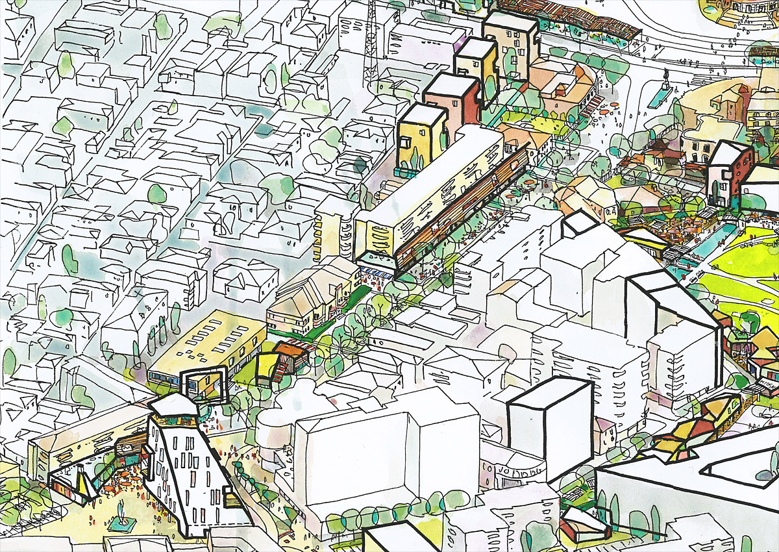

*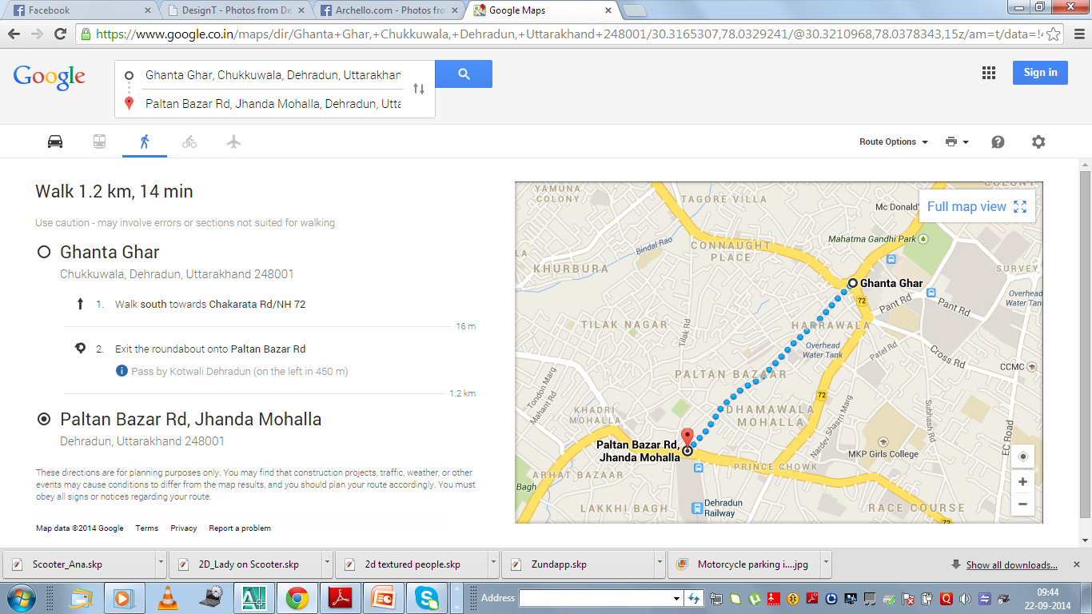Project Area Stretch length*

*The projects area’s length is approximately 1.2 kilometres and starts from Clock tower area and ends at lakhih bagh t jucntion. Without any delay the total journey can be completed in 14 minutes. During the journey one has to pass through Dhamawala bazar Patlan bazar and other small bazaars. The area is congested and the delay period increases while the journey. The total stretch is very congested and the abutting land is commercial in nature. The chakrata road, dispensary road, Gandhi Road, Clock Tower, Rajpur Road, Saharanpur Road, Tilak Road, surround this road from various directions.*

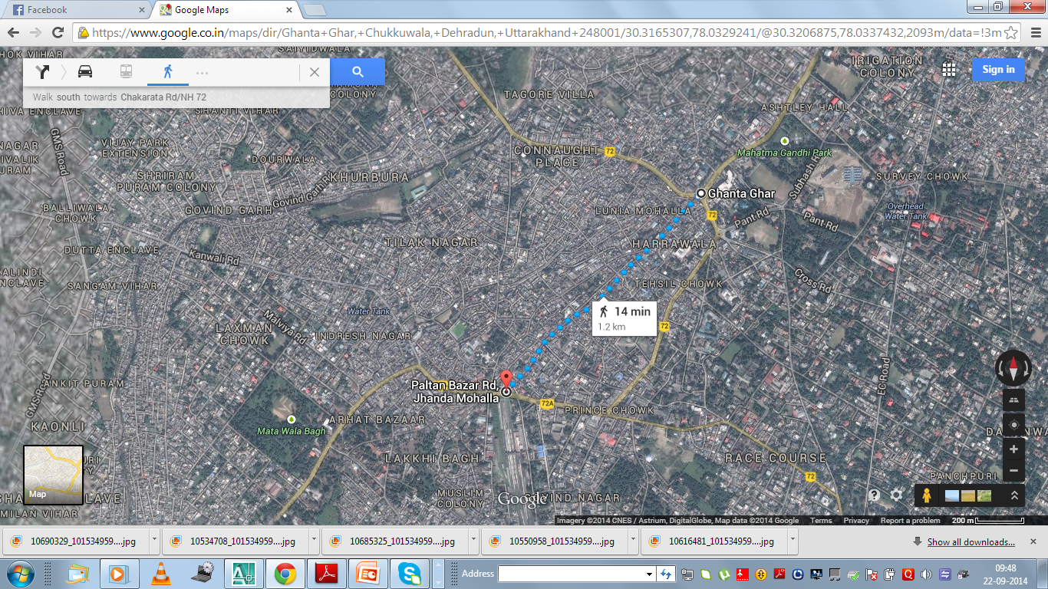

*The market Janda wala area, Moti Bazar, Dhamawala Bazar, Paltan bazar, Dispansary Market, Ghosi gali, Sarfa Bazaar Addahat Bazar Surround this road stretch, the footfall on this road stretch is very high during the survey it was noticed that pedestrians cant walk on the footpath as the footpath in this area is encroached upon by shop keeps and other small vendors. The parking on both side of the road leaves very less space for the pedestrians and traffic movement. So it is important to increase the carriageway space for free flow of the traffic.*

*Present Traffic Condition*

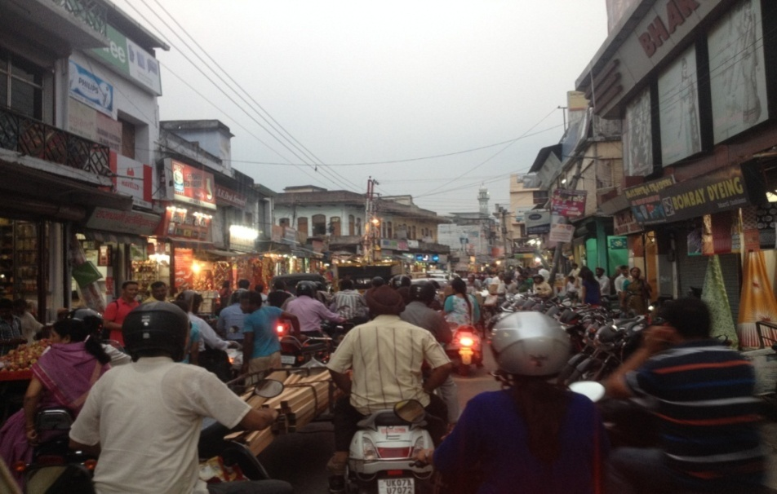

*Congestion and mix traffic condition along with encroachment and parking effect the free and safe flow of the traffic, high parking demand also affects the overall traffic scenario in the area.*

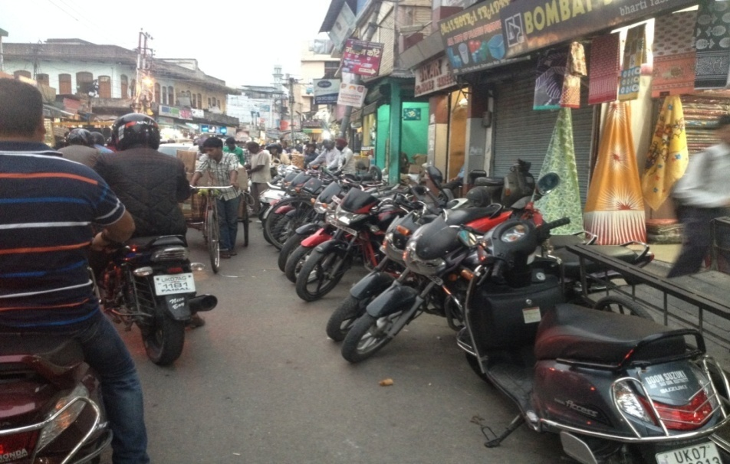

*Encroachment on footpath and parking of two wheelers users on both side of the road decrease the width of the carriage and create bottle situation in the area.*

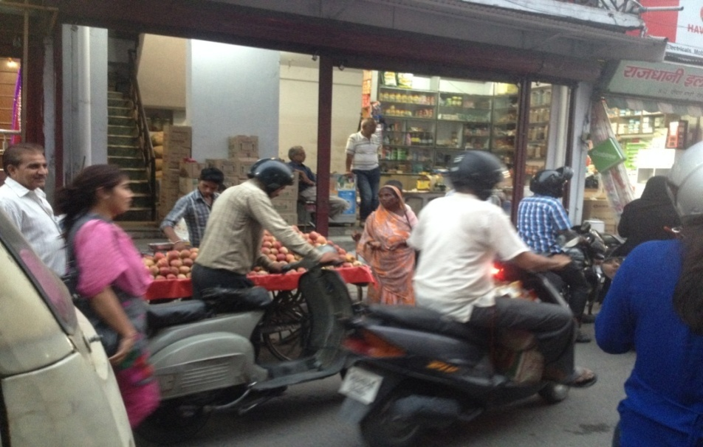

*Encroachment on footpath by rehriwalas and street vendors also effect the free flow of the traffic*

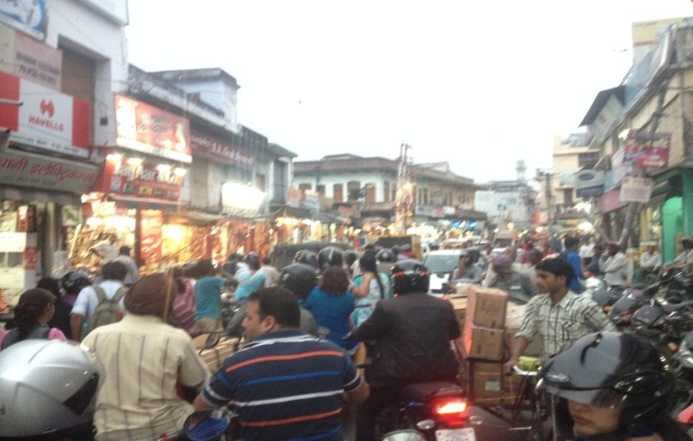

*Heavy traffic movement in the evening hours along with the parking on the both sides of the road affect the free flow of the traffic. The slow moving vehicles also effect the speed of the vehicles.*

*Digital Map of the route and parking.*

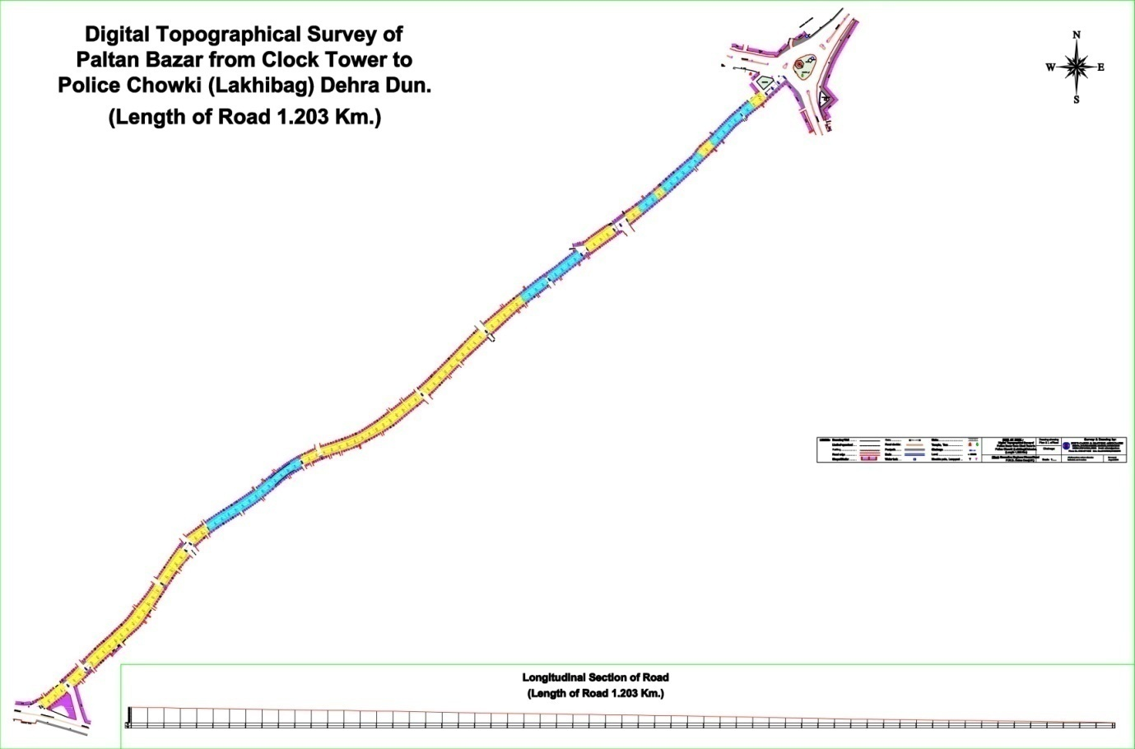

*In the above given digital map of the route from clock tower to lakhi bagh police chowki the route has been divided into two divisions.*

1. ***The route length with yellow colour.***

*The route length marked with yellow colour is the route where road width is greater than 10 meters and in this zone parking of the two wheelers can be done in the central part of the road within markings and will also help in segregation of the lanes. In the zone with yellow colour parking will be permitted for two wheelers.*

1. ***The route length with blue colour.***

*The route length marked with blue colour is the route where road width is less than 10 meters and in this zone parking can’t be done in the central portion or in the sides. As the road width in this zone is less than 10 mts therefore parking can’t be allowed in this area. The agency has to properly and precisely mark that area with solid double lines or single solid line or as per the IRC guidelines.*

*Zone where parking is allowed*

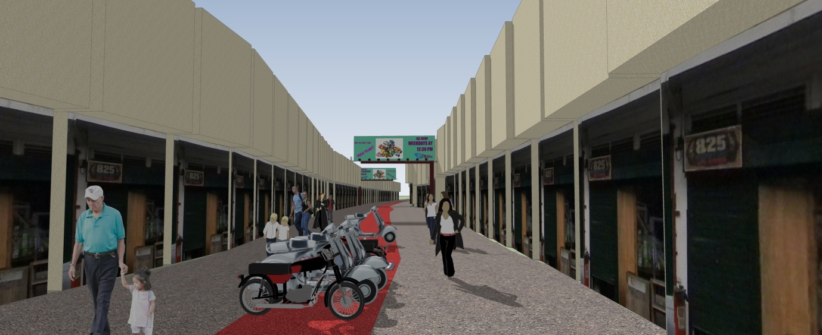

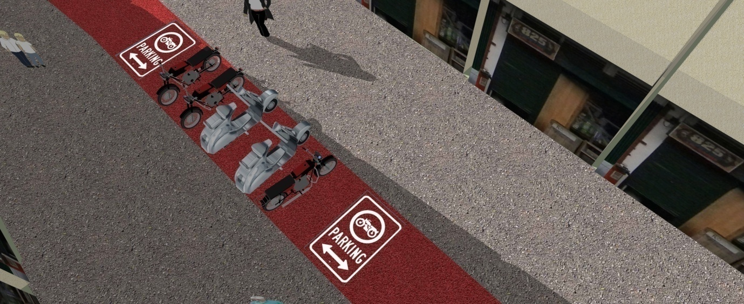

*The parking will be done only in the zone where the width of the road is more than 10 mts and the parking area is precisely marked with road markings, the road users have to park their vehicles in the specified area. The road making & the parking signage’s have to be marked on road, instead of installing mounted signage’s to save as much as precious space can be saved. The marking has to be done in very precise manner and in accordance with IRC and other regulations. The place where the road width is less than 10 mts single solid lines shall be marked and parking will not be allowed for the public*

*Zone where parking is not allowed*

*The zone where parking is not allowed as the width of the road is less than 10 meters; the road stretch shall be marked with single solid lines.*

*Existing plan of the road stretch (Existing Condition).*

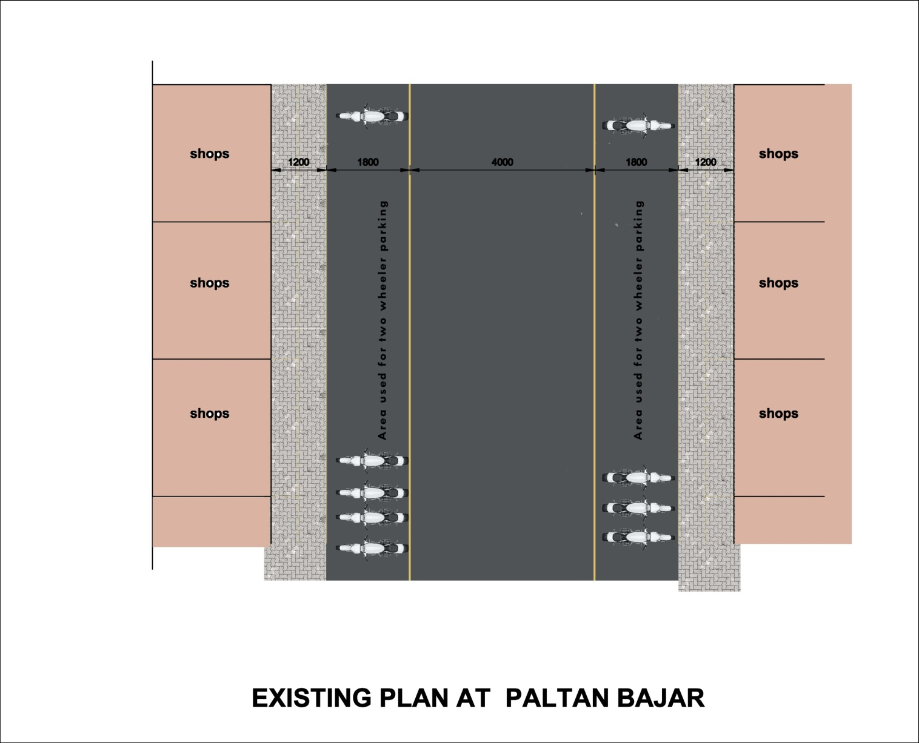

*The existing plan of the this road stretch shows that out of the total right of way width footpath covers approximately 2400 mm. The parking done by two wheelers covers approximately 3600 mm and the rest 4000 mm is left for the movement of the traffic.*

*Indicative proposed plan of the road (Proposal)*

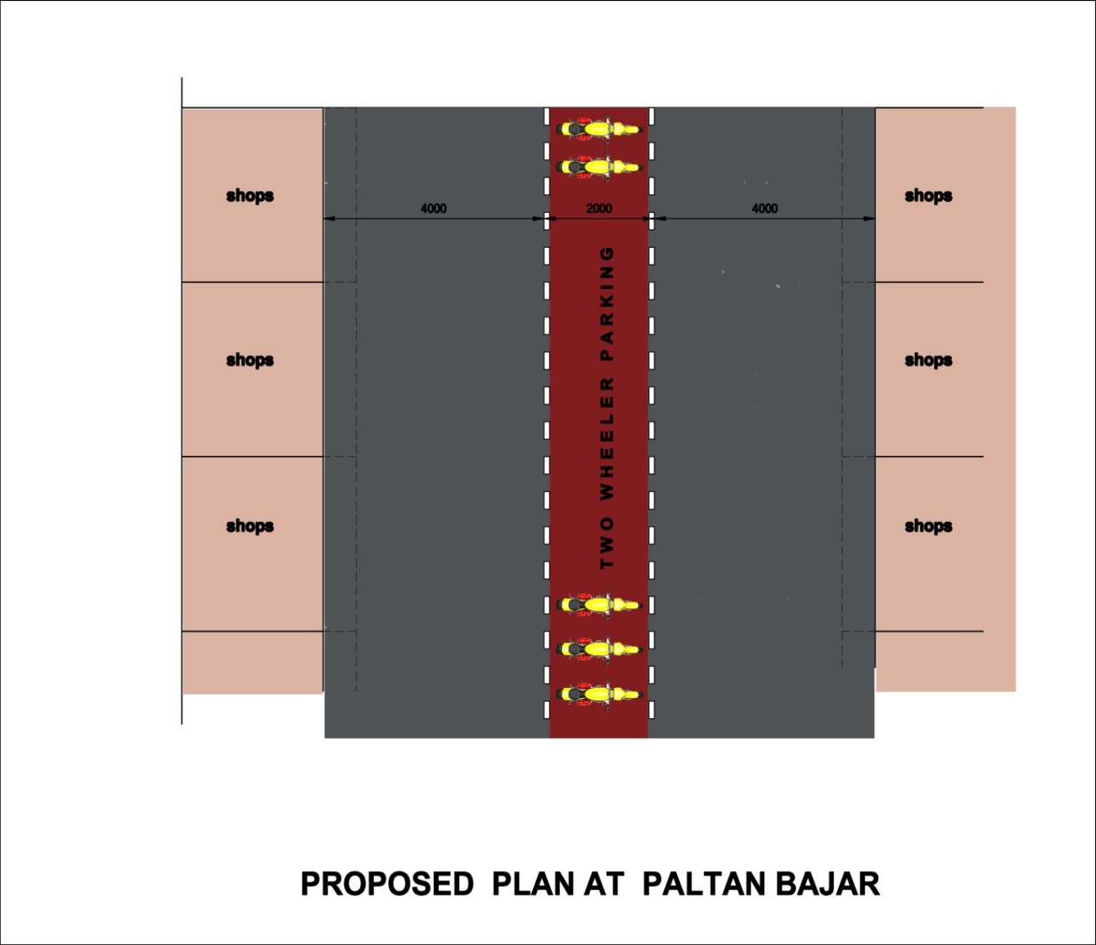

***Zones where road width greater than 10 meters***

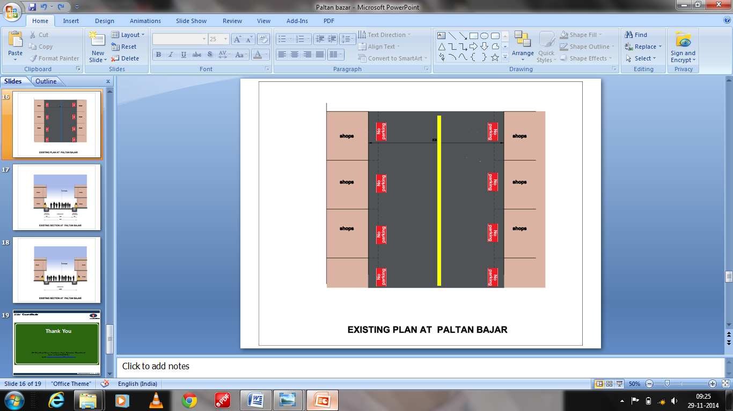

***Zones where road width is less than 10 meters***

*In the proposed plan of the footpath which is encroached by shop keepers and vendors will be dismantled to the carriageway level, the places where the width of the road is more than 10 meters the central portion after precise marking will be used for parking and segregation of traffic. The electric poles will be shifted backwards with arm extending forwards in cantilever shape for safety. This shifting of the poles will be done by the UPCL but the expenses of shifting of the poles (cost) will be paid by the successful bidder. For his purpose municipal corporation shall act as a facilitator for the obtaining the permissions etc.*

*Indicative Proposed sections of the road (Proposal)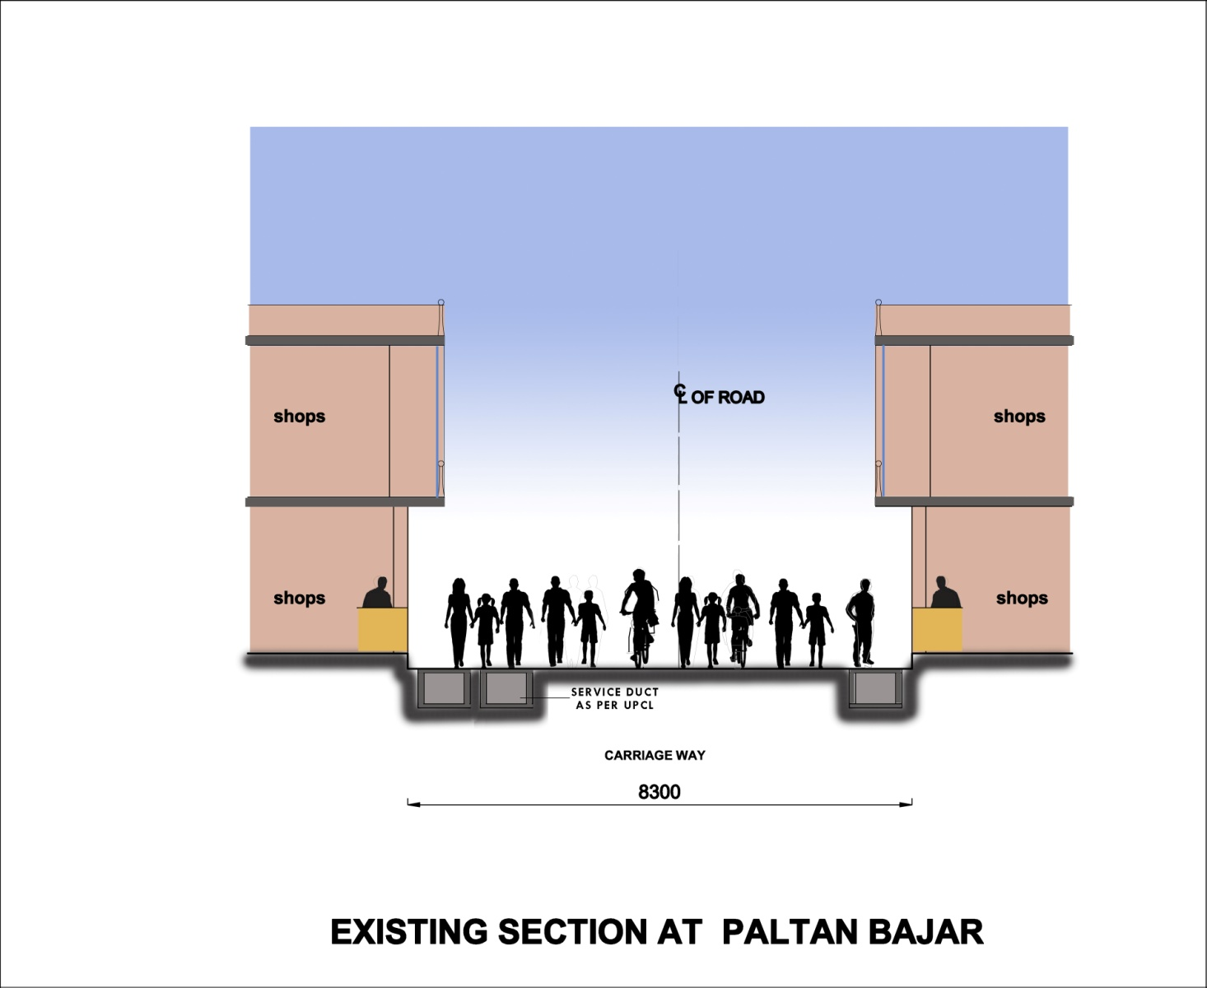*

*Indicative Proposed section of the zone where road width is less than 10 mts*

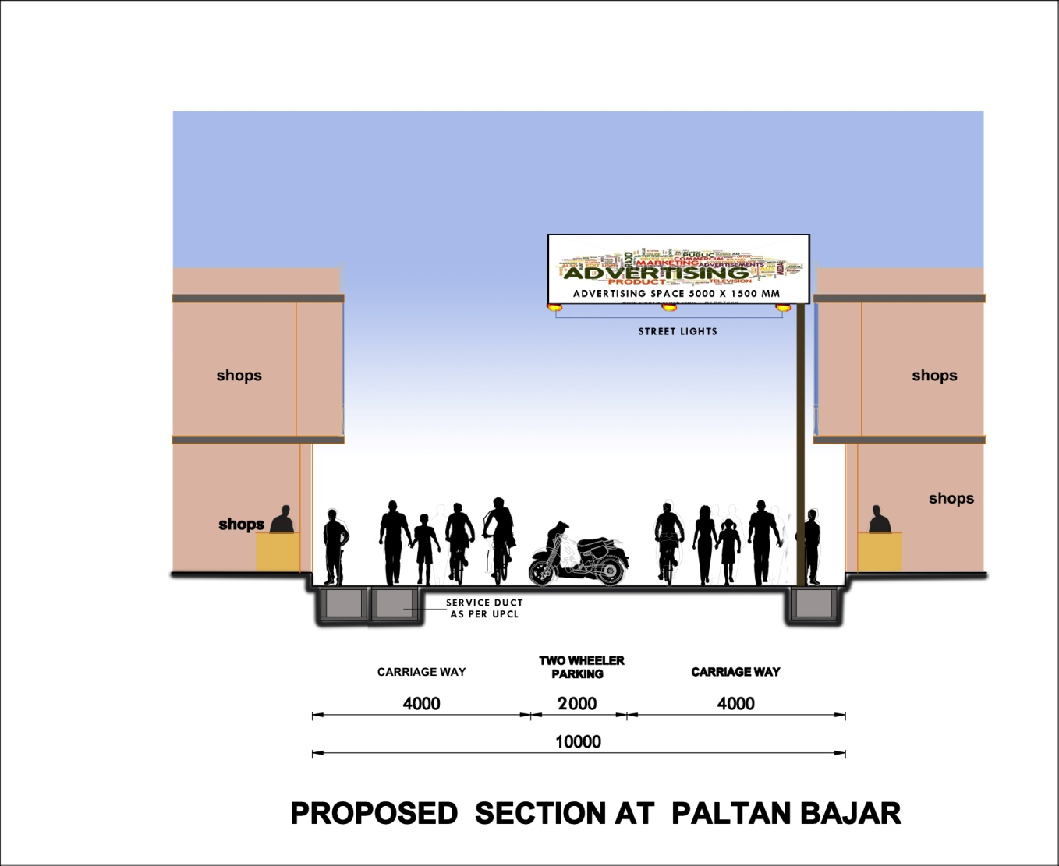

*Indicative Proposed section of the zone where road width is more or equal to 10 mts*

*SCOPE OF WORK:*

* 1. *The scope of WORK for the project is to design, Built, Finance operate & transfer of all facilities including Advertisement Boards at route stretch selected by Nagar Nigam, Dehradun in conformity to the provisions of this RFP and License Agreement; & meet the requirements laid down by the Nagar Nigam Dehradun and other related Competent Authorities.*
  2. *The successful bidder can install or display advertisements (either himself or through any of his associated agency) on the overhead ADVERTISEMENT BOARDS for a period of 20 years including 1 year period for completing all the construction job which includes dismantling of Footpath, levelling of drain with road level, shifting of poles, installation of street lights on advertisement boards, construction of service duct, marking road markings for the beautification of Paltan bazar road from Clock tower junction to Lakhi bagh t junction from the date of signing of contract. Bidder shall born the cost of Design, Build, Finance, Operation Maintenance and Transfer of all the facilities in fully functional condition keeping in consideration the safety of the pedestrians, public convenience air circulation & the safety of the road users who will pass through the area etc.*
  3. *License period shall be for 20 years including 1 year period for construction and installation of all the facilities from the date of signing of agreement irrespective of when the successful bidder is able to actually build and install all the facilities at the road section selected in the project area.*

**

*PPP MODE: Design Built finance Maintain Operate and Transfer for the period of 20 years against the right to display advertisements. Minimum 24 & maximum 30 advertisement boards can be installed. Each advertisement board has to be installed after 50 meters. Advertisement can be installed on both sides of the advertisement boards*

***The scope of the work also includes***

1. *Repairing of existing Drain on both sides of the road.*
2. *The successful bidder shall submit the design of the drain and the service duct. Compact design with all safety measures.*
3. *The service ducts will be for Electric and telephone lines on both side of the road.*
4. *The provisions for down pipe will be provided.*
5. *The provision for surface run-off of water has to be provided.*
6. *Dismantling of footpath.*
7. *Construction of service duct for utility lines as per UPCL, BSNL and the norms of other related agencies guideline on both side of the road.*
8. *Levelling of the drain height with the road level.*
9. *The successful bidder shall have to Install 72 LED lights on the pole beneath the advertisement boards. For this purpose 3 lights shall be installed on each advertisement board with automatic timer system. The successful bidder can use the solar based LED light. The cost of installation of solar system shall be borne by the successful bidder in case the solar system is not opted the electricity bill charges shall be borne by the successful bidder*
10. *Minimum 24 & maximum 30 advertisement overhead signboards will be allowed to be installed after every 50 meters. The size of the advertisement board will not be more than 5000 mm *1500 mm \**
11. *Road marking shall be marked precisely as per IRC guidelines. Which includes edge marking central lane marking, marking for parking area, zebra crossing etc.*
12. *The excavation work has to be does in such a way that it does not affect the movement of traffic and has to be safe in nature for all stakeholders.*

*The selected bidder will have to submit three different DPR’s for the project mentioned as under.*

1. *DPR of the project in which only drain has be reconstructed, footpath has to be levelled with road level both sides.*
2. *DPR of the Project in which drain has be reconstructed, footpath has to be levelled with road level with a compact single service duct for only electric and telephone lines. On both side of the road. The size of the duct has not to be more than 2 feet wide, 2 feet deep.*
3. *DPR of the project in which drain has to be reconstructed, footpath has to be levelled with road level with the separate service ducts for all utility lines (Electric line, telephone line, & Water supply) on both side of the road.*

*The successful bidder will quote the user charges & share percentage between Nagar Nigam and successful bidder to be taken from the users for using the service ducts. The user charges will be fixed and prepared on the basis of the cost of the construction and other related charges related to the project. The charges will be mutually fixed by Nagar Nigam and PWD*

***Note: The scope of work can be increased or decreased depending upon the prevailing circumstances, availability of land and competence of the Successful bidder or any other issue which affects the work of the project.***

*GENERAL SPECIFICATIONS OF THE PROJECT*

* 1. *The design of has to be the best in the industry & as per the ongoing practices.*
  2. *The design has to be according to the specifications used by any other agency which have already undertaken and successfully completed such kind of work in India or outside India.*
  3. *The successful bidder will prepare the digital map of the route from clock tower junction to Lakhi bagh police chowki and accordingly design. The proposals and sugeestions given by the Nagar Nigam Dehradun has to be considered and the suggestions have also to be incorporated into the new plan before submitting their proposal for approval*
  4. *Water proofing of the service duct has to be done.*
  5. *The design has to be very aesthetical in nature.*
  6. *The Nagar Nigam will approve the design before implementation.*
  7. *The design has to be safe in all aspects.*
  8. *The design should be such that it doesn’t affect the free, smooth and safe movement of the traffic.*

*SECTION 2 – INSTRUCTIONS TO BIDDERS*

*2.1 INSTRUCTIONS TO BIDDERS:*

* 1. *Bidders should submit their proposals on time.*
  2. *Bidders are required to read carefully the contents of this document including Technical Capabilities.*
  3. *Bidders have to complete the Request for proposal and provide all the other documents/information in sufficient detail. The completed Request for proposal application form and other documents must be prepared and submitted in original, and must be so marked. Submittals from bidders will be evaluated on the basis of their experience and their technical, administrative and financial capability to perform the contract. Poor past performance record such as abandoning of works; not properly completing contracts; litigation history, financial failure etc. may lead to rejection.*
  4. *All documents must be in English language and each page of the Request for proposal Application Form must be duly completed. Each page of the Request for proposal document must be signed, numbered & stamped as a token of acceptance of the terms & conditions of the Contract. Any unsigned and unstamped document will not be considered.*
  5. *Only the successful bidder will be informed of the result. The bidder hereby acknowledges and agrees that NAGAR NIGAM DEHRADUN will not be obliged to discuss any aspect of the Request for proposal process.*
  6. *Bidders should note clearly the last date and time of submittal of the bid applications. No late or delayed applications will be accepted. Bidders are reminded that no supplementary material will be entertained by NAGAR NIGAM DEHRADUN. However NAGAR NIGAM DEHRADUN may, if necessary, at its sole discretion ask for any clarification regarding the submitted Request for proposal and/or other documents.*
  7. *Bidders and/or successful bidder who are/is found to made any misleading or false representations in the Request for proposal including any statements, attachments, document, Performa’s & annexure submitted as proof of the requirements, shall be disqualified.*

1. *SCHEDULE OF SELECTION PROCESS:*

*Request for proposal FOR PALTAN BAZAR BEAUTIFICATION project ON PPP BASIS against rights of display advertisements for a period of 20 years including 1 year of construction in Dehradun is hereby scheduled as under :-*

***Table number 1: - Schedule of selection process***

|  |  |  |  |
| --- | --- | --- | --- |
| ***Sl.*** | ***Activity*** | ***Date And Time (IST)*** | ***Venue*** |
| ***1*** | *Issue of Bid Document* | *12-01-2015* | ***Nagar Nigam Dehradun.*** |
| ***2*** | *Pre –bid Meeting, Presentation and finalization of design.* | *24-01-2015 at 11-00 AM* |
| ***3*** | *Submission of proposal* | *24-01-2015 to 02-02-2015 till 3:00PM* |
| ***4*** | *Opening of Technical Bid* & *presentation* | *04-02-2015 at 3:00 Pm* |
| ***5*** | *Opening of Financial Bid* | *(10-02-2015 at 3 pm)* |
| ***6*** | *Note: - No offer will be accepted after the last date and time of the schedule* | |

*In case of government Holiday or restricted holiday or announcement of a day as holiday by the state or central government, the activity related to the Bid Proposal shall be transfer/ commence to next working day.*

*Bidders have to submit the Earnest Money deposit of Rs. 350000 INR (Rs. Three lakh fifty thousand only) which is to be deposited at the time of submission of Request for Proposal documents in the form of Demand Draft in the favour of Mukhya Nagar Adhikari, Nagar Nigam Dehradun.*

*2.3 TECHNICAL AND FINANCIAL QUALIFICATION CONDITIONS:*

*The bidder can be a Proprietor, partnership firm, public or private limited company incorporated under the provisions of Indian Companies Act, 1956. The bidder should be legally competent to enter into contract as per prevailing laws. Only those bidders meeting both the following capability criteria will be “Qualify” for the project and will be considered further.*

1. *Technical/Financial Qualification*

*Firms who fulfil the following requirements shall be eligible to apply:-*

1. *The agency shall have experience of construction, operation and maintenance of street furniture or any other PPP project in Dehradun or any major city of India.*
2. *Minimum Five years of experience in the field of INSTALLING street furniture & outdoor advertising.*
3. *The minimum annual turnover of the agency shall be Rs.50 Lac for each of the last three years.*
4. *EXPLANATIONS FOR THE PURPOSE OF TECHNICAL QUALIFICATION:* 
   1. *The bidder must submit completion certificate for each of the experience claimed issued by the client and adequate documentation (like certification from clients, letter of acceptance, agreement etc.) for running contracts.*
   2. *The Bidder must submit Audited Annual Reports, Balance Sheet and Profit Loss Accounts with Schedules forming part of annual accounts of the last 3 (three) years.*
   3. *STATUTORY CLEARANCES:*
5. *The licensee will be fully responsible for the aesthetic maintenance of all the facilities and structures, build by him. All facilities and structures to be built up shall have to comply with standard safety norms. No claims or compensation or damages whatsoever will be entertained by NAGAR NIGAM DEHRADUN on this account.*
6. *The licensee will adhere to comply with all notices and circulars issued from the office of NAGAR NIGAM DEHRADUN from time to time.*
7. *The licensee shall be liable for all the statutory clearances to be obtained from concerned departments , Nagar Nigam shall may just facilitate in obtaining such clearances*
8. *RIGHT TO REJECT LICENCE:* 
   1. *NAGAR NIGAM DEHRADUN reserves the right to reject any / all Request for proposal or withdraw the site of the Request for proposal at any stage without assigning any reasons. Nothing contained herein shall confer right upon a bidder or any obligation upon NAGAR NIGAM DEHRADUN.*
   2. *No claims or compensation or damages whatsoever will be entertained by NAGAR NIGAM DEHRADUN on this account.*
9. *MISREPRESENTATION / FRAUD/ BREACH OF TERMS AND CONDITIONS:*

*If it is discovered at any point of time that the bidder has suppressed any fact or given a false statement or has done misrepresentation or fraud or has violated any of the terms of this bid, the bid will be cancelled by the NAGAR NIGAM DEHRADUN. In such an event, the bidder will not be entitled to any compensation whatsoever, or refund of any other amount paid by him.*

1. *EARNEST MONEY DEPOSIT:*
2. *The Bidder shall submit an interest free Earnest Money Deposit (EMD) of Rs. 350000INR (Rs. Three lakh fifty thousand INR only) in the form of Demand Draft in favour of Mukhya Nagar Adhikari, Nagar Nigam Dehradun., drawn on any scheduled commercial bank acceptable to NAGAR NIGAM DEHRADUN and payable at Dehradun along with the proposal.*
   1. *Any offer, which is not accompanied by the requisite Earnest Money Deposit, shall be rejected outright.*
   2. *The EMD submitted by the successful Bidder may be adjusted in the performance security.*
   3. *The EMD of the bidders shall be returned in accordance with clause 3.18 & 3.19*
   4. *The EMD shall however be forfeited in the following cases:*

*If the bidder withdraws its proposal (offer) during the interval between the Proposal due date and expiration of the Proposal Validity Period;*

* + 1. *If the successful bidder fails to unconditionally accept the Letter of Acceptance in writing, within the time specified in this document, or any extension thereof granted by NAGAR NIGAM DEHRADUN.*
    2. *If the successful bidder fails to sign the License agreement and/or make the performance security within the time specified in this document, or any extension thereof granted by NAGAR NIGAM DEHRADUN.*

1. *PROPOSAL PREPARATION COST:*

*The Bidder shall be responsible for all the costs associated with the preparation of its Proposal and its participation in the bidding process, including all types of due diligence in the process. NAGAR NIGAM DEHRADUN will not in any way be responsible or liable for such costs, regardless of the conduct or outcome of bidding.*

1. *DUTIES AND TAXES:*

*All duties, taxes and other levies payable by the bidder in respect of the transaction between the bidder and their vendors/sub-suppliers shall be included in the bid price and no claim on this behalf will be entertained by the Authority. All taxes, duties and levies (except service tax) in respect of the transaction between the nagar nigam and bidder shall be included in the bid price.*

1. *VALIDITY OF PROPOSAL:*

*The Proposal shall remain valid for a period not less than Ninety (90) days from the date of opening of financial bid (Offer Validity Period). NAGAR NIGAM DEHRADUN reserves the right to reject any Proposal that does not meet this requirement. Validity of proposal shall be extended for a specified additional period at the request of NAGAR NIGAM DEHRADUN.*

*A bidder agreeing to the request will not be allowed to modify the proposal, but would be required to extend the validity of its EMD for the period of extension.*

1. *DISPUTE RESOLUTION:*

*If any dispute arises out of the contract with regard to the interpretation, meaning and breach of the terms of the MoU or from the work of operation, firstly the matter shall be resolved amicably if the matter does not resolve then it should be settled as per Arbitration and conciliation Act 1996 with its amendments from time to time.*

*1. Arbitration Procedure*

*If the efforts, to resolve all or any of the disputes amicably fail, then such a dispute shall be referred to a Sole Arbitrator who would be appointed by Mukhya Nagar Adhikari, NAGAR NIGAM DEHRADUN, Dehradun. The venue of such arbitration shall be at Dehradun. The award of the sole Arbitrator shall be binding on both the parties. The cost of Arbitration shall be borne by both the parties.*

1. *Place of Arbitration*

*The place of arbitration shall be Dehradun.*

1. *Language*

*The request for arbitration, the answer to the request, the terms of reference, any written submissions, any orders and awards shall be in English, Hindi and, if oral hearings take place, English & Hindi shall be the language to be used in the hearings. The award shall be made in writing.*

*4. Enforcement of Award*

*The Parties agree that the decision or award, which shall be a written order, resulting from arbitration shall be final and binding upon both the Parties and shall be enforceable in accordance with the Provision of the Arbitration and Conciliation Act.*

*5. Performance during Arbitration*

*The Arbitration Proceedings shall be governed by Indian Arbitration and Conciliation Act 1996, as amended from time to time including provisions in force at the time the reference is made. Pending the submission of and/or decision on a Dispute and until the arbitral award is published; the Parties shall continue to perform their respective obligations under this Agreement without prejudice to a final adjustment in accordance with such award.*

*The courts at Dehradun shall have the sole exclusive jurisdiction to try all the cases arising out of this agreement.*

1. *NOTICES:*

*That any notices served shall be in writing and send by registered post or delivered personally and signed by the party or his/its duly authorised representative giving such notice. All activities including day to day management, billing, termination etc. will be carried out from the office of the MNA, NAGAR NIGAM DEHRADUN, Dehradun or by his duly authorised representative. Notice shall be addressed as follows:*

*If to NAGAR NIGAM DEHRADUN at*

*Mukhya Nagar Adhikari,*

*Nagar Nigam Dehradun,*

*Uttarakhand India*

*If to the LICENSEE: - At Address as given by licensee in bid document.*

1. *COMMUNICATION WITH NAGAR NIGAM DEHRADUN:*

*Communication/correspondence to NAGAR NIGAM DEHRADUN will be done by a nodal member duly appointed by successful bidder, throughout the license period.*

1. *SUBMISSION OF DESIGN AND PLANS BY THE SUCCESSFUL BIDDER:*

*The successful bidder would submit the DPR along with action plan to NAGAR NIGAM DEHRADUN for approval before commencing the development work to develop and construct and beautify the paltan bazar road from clock tower junction to lakhhi bagh junction. The DPR should also include: -*

* 1. *Submission of Drawings of the whole project based on the concept prepared by Nagar Nigam.*
  2. *Quality Assurance Plan*
  3. *Construction Plan*
  4. *O&M Plan- Construction Period*
  5. *Time & work schedule for construction / completion of the project.*
  6. *List of Technical Manpower and staff employed. Total detail.*
  7. *Detailed Estimates of the project.*
  8. *Details of material resources.*
  9. *List of Machines to be used during construction.*
  10. *Work Schedule etc.*
  11. *Vehicular movement drawing.*

*SECTION - 3: REQUEST FOR PROPOSAL SCHEDULE*

*3.1 BID DOCUMENT FEES:*

*Interested parties are required to purchase bid document from the office of the Nagar Nigam Dehradun on payment of Rs. 10,000/- + 12.36 % service tax (non-refundable) by way of Demand Draft in favour of Nagar Nigam Dehradun; payable at Dehradun.*

1. *PREPARATION AND SUBMISSION OF PROPOSAL:*

*Bids should be submitted in the forms prescribed under this section and relevant annexure in Section 5.*

* 1. *Completed proposals shall be accepted only upto (00-00-2014) 3 pm on scheduled date in the office of MNA, NAGAR NIGAM DEHRADUN, Dehradun.*
  2. *Bidders shall furnish the information strictly as per the formats given in Section 5 of this document and without any ambiguity. NAGAR NIGAM DEHRADUN shall not be held responsible if the failure of any bidder to provide the information in the prescribed formats results in lack of clarity in interpretation and consequent disqualification.*
  3. *The proposal shall be initialled on each page by the Authorized Signatory in acceptance of all terms and conditions of this Request for proposal. All the alterations, omissions, additions, or any other amendments made to the Proposal shall also be initialled by him.*
  4. *All witnesses and sureties shall be the persons of status and probity and their full names and addresses shall be stated below their signature. All signatures in the Proposal documents shall be dated.*
  5. *Bidders are required to submit only one set of the Proposal, including the Original Request for proposal Document issued to them signed on each page in acceptance of all terms and conditions of this RFP. Any individual, firm or company which submits or participates in more than one Proposal for the said project shall be disqualified and shall also cause the disqualification of all the Consortia in which it is a Member.*
  6. *All the bidders will be sent clarifications to queries, till the stipulated date. The queries received after the prescribed date will not be entertained by NAGAR NIGAM DEHRADUN. All the bidders are requested to monitor the NAGAR NIGAM DEHRADUN website for the same.*
  7. *PAYMENTS TO NAGAR NIGAM DEHRADUN:*
  8. *Successful bidder shall have to pay the license fee for each year in advance. The License fee has to deposit before the signing of Agreement.*
  9. *The license fee shall be increased by 10% every two years for the rest of the license Period.*
  10. *Any delay in payments in the preceding clauses shall entail payment of interest @15% per annum on the amount outstanding, for the days of default. Delays beyond 30 days of the due dates for recurring payment, milestones will be treated as Licensee Events of Default. In such an eventuality NAGAR NIGAM DEHRADUN retains the right to forfeit Performance Security and claim damages from the licensee and even terminate the agreement*

1. *LANGUAGE AND CURRENCY:*
2. *The Proposal and all related correspondence and documents shall be written in English and Hindi language.*
3. *The currency for the purpose of the Proposal shall be the Indian National Rupee (INR).*
4. *SIGNATURE OF BIDDER:*

*The bid must contain the name, residence and place of business of the authorized person or persons making the bid and must be signed by the Bidder/applicant with his usual signature. The names of all persons signing shall be stamped, typed or printed below the signature. Bids by Corporation / company must be signed with the legal name of the Corporation / Company by the President / Managing Director or other person or persons authorized to bid on behalf of such Corporation / Company in the matter. Significant evidence of authority of the person signing on behalf of the Bidder/ applicant in the form of Power of Attorney shall be furnished with the Bid.*

1. *SEALING AND MARKING OF PROPOSALS:*

*The Proposals shall be sealed, marked and submitted as explained below:*

1. *Envelope No.1 shall contain the Earnest Money Deposit and shall be marked as Earnest Money Deposit.*
2. *The Qualification documents shall be sealed in a separate (Envelope No. 2) duly marked as TECHNICAL QUALIFICATION and shall contain the following:*

*Letter of Interest (As per Annexure 1)*

*General Information of the Bidder (As per Annexure 2)*

*Summary of Technical Capability (As per Annexure 3)*

*Summary of Financial Capability (As per Annexure 4)*

*Attested (by Gazetted officer) copy of the Partnership deed in case of a partnership Power of Attorney for Signing of Request for proposal Original Request for proposal Document duly signed (on each page) by an authorized representative as a token of acceptance of all terms and conditions*

1. *The Bidder shall seal the Financial Proposal (as per Annexure 5) in a separate third envelope (No. 3) duly marked as FINANCIAL BID.*

*The Outer envelope shall be addressed to:*

*Mukhya Nagar Adhikari,*

*Nagar Nigam Dehradun,*

*Uttarakhand India*

1. *If the envelopes are not sealed and marked as instructed above, NAGAR NIGAM DEHRADUN assumes no responsibility for the misplacement or premature opening of the Proposal submitted.*
2. *Any Proposal received by NAGAR NIGAM DEHRADUN after 15.00 hrs on the Due Date will be liable to rejection.* 
   1. *BIDDERS RESPONSIBILITY:*

*It would be deemed that prior to the submission of Proposal; the Bidder has made a complete and careful examination of:*

1. *The requirements and other information set forth in this Request for Proposal document.*
2. *All the sites, existing facilities, encumbrances on every site and structures, access roads and utilities in the vicinity of every site.*
3. *All other matters that might affect the Bidders performance under the terms of this RFP document, including all business potential, risks, costs, liabilities and contingencies associated with the project and that proposals/ bids/offers have been signed by the bidder or the duly authorised signatory of the bidder.*
4. *NAGAR NIGAM DEHRADUN shall not be liable for any mistake or error or neglect by the Bidder in respect of the above. Proposals that are not substantively responsive to the requirements of this Request for proposal document will be rejected.*
5. *MODIFICATION AND WITHDRAWAL OF PROPOSALS:* 
   1. *No Proposal shall be modified or withdrawn by the Bidder after the Submission of Proposal.*
   2. *Withdrawal of a Proposal during the interval between Proposal due date and expiration of the Proposal Validity Period would result in forfeiture of the EMD.*

*3.9 OPENING OF BIDS****:***

*3.9.1 The Technical bids received shall be opened by a Committee constituted by the Mukhya Nagar Adhikari, NAGAR NIGAM DEHRADUN, Dehradun in the presence of the bidders at 3 pm on scheduled submission date, unless intimated otherwise. The date for opening of financial bids shall be intimated in advance to the technically qualified bidders.*

1. *NAGAR NIGAM DEHRADUN reserves the right to reject any Proposal and forfeit the EMD, if* 
   1. *It is not signed, sealed and marked as stipulated in Clause 3.6.*
   2. *The information and documents have not been submitted as requested and in the formats specified in the Request for Proposal document.*
   3. *There are inconsistencies between the Proposal and the supporting documents.*
   4. *It does not mention the validity period as set out in Clause 2.11.*
   5. *It provides the information with material deviations, which may affect the scope or performance of the Project.*
   6. *There are conditions proposed with the Technical and/or Financial Proposals.*
2. *A material deviation or reservation is one:*
3. *which affects in any substantial way, the scope, quality, or performance of the Project, or*
4. *which limits in any substantial way, inconsistent with the Request for Proposal document, NAGAR NIGAM DEHRADUN rights or the Bidders obligations, or*
5. *Which would affect unfairly the competitive position of other Bidders presenting substantially responsive bids?*

*No request for modification or withdrawal shall be entertained by NAGAR NIGAM DEHRADUN in respect of such Proposals.*

*3 .10 EVALUATION OF PROPOSAL:*

*The evaluation will be done in two stages as explained below*

*1. In Stage - I, the EMD in Envelope 1 shall be first checked. Proposals without the appropriate EMD will be rejected. Thereafter, Envelope 2 containing the Technical Qualification Documents submitted by the Bidders will be opened. The Request for proposal not meeting the prescribed technical and financial capability criteria as per clause 2.3 will be rejected. The qualifying criteria for the technical bid shall be as follows.*

*QUALIFYING CRITERIA:*

|  |  |  |
| --- | --- | --- |
| *S. No.* | *Description* | *Max. Marks* |
| *1.* | *Registration of Proprietor/ Private limited/Partnership firm* | *10* |
| *I* | *Company’s/firm Registration Certificate* | *4* |
| *II* | *Registration under Trade Tax, ,VAT/Service Tax* | *2* |
| *III* | *Establishment years of the organization (3Y=2/3Y-5Y=3/<5Y=4)* | *4* |
| *2.* | *Experience* | *20* |
| *I* | *Experience of Street Furniture projects on BOT basis in last five years (Greater than Rs. 3 crore but less or equal to 5 crore = 5/ Greater than Rs. 5 crore but less or equal to Rs. 8 crore = 7/ Greater than Rs. 8 crore =10)* | *10* |
| *II* | *Successful O & M experience in last five years* | *10* |
| *3.* | *Financial* | *20* |
| *I* | *Turnover (less or equal to 70 Lakh =5, more than 70 Lakh =10)* | *10* |
| *II* | *Net worth (less or equal to Rs 50 lakh =5, more than 50 lakh =10)* | *10* |
| *4.* | *Presentation (Company profile, Same field experience, equipments, manpower, technology use etc)* | *40* |
| *5.* | *Completion Schedule (Pert cart/MS)* | *10* |
|  | *Total* | *100* |

1. *The bidder should obtain minimum 60 marks out of the 100 of “Qualifying Criteria” to get shortlisted for financial stage.*
2. *Disqualified bidder will be informed in writing through FAX/Mai/Email.*
3. *Bidder(s) may please note that their offers will be evaluated as per the credentials or documents attached by them along with the RFP.*

*In Stage-II of evaluation, the financial bids in Envelope 3 of only those bidders who have passed Stage I shall be opened by NAGAR NIGAM DEHRADUN in presence of the nominees of the bidders who have passed Stage-I. Bidders shall be ranked HI, H2, H3, etc. in decreasing order of their financial offers. The selection will be on the basis of marks obtained according to the following Qualifying Criteria.*

*NAGAR NIGAM DEHRADUN would have the right to review the RFP and seek clarifications where necessary. The response from the Bidder(s) shall only be in writing but no change in the substance of the Proposal would be permitted. It is clarified that bidders are free to make suggestions but are not allowed to submit any conditional bid as specified earlier.*

*Financial Proposals of Bidders who do not qualify the Stage-I of technical evaluation will not be opened.*

*NAGAR NIGAM DEHRADUN reserves the right to reject any proposal submitted by bidders if it is of the opinion that the bidder lacks the expertise, experience and is not in possession of requisite infrastructure required for the purpose of the project. The discretion of MUKHYA NAGAR ADHIKARINAGAR NIGAM DEHRADUN in this respect shall be final and binding on all bidders****.***

1. *AWARD OF CONTRACT:*

*The contract would be awarded to the best qualified and responsive Bidder offering the bid in conformity with the requirements of these specifications and documents and the nagar nigam shall be the sole judge in this regard*

*Notification on Award of Contract will be made in writing to the successful Bidder by the nagar nigam The selection of bidder/applicant will be at the sole discretion of the nagar nigam and nagar nigam reserves the right to accept or reject any or all the bids without assigning any reason. The nagar nigam reserves the right to call for additional information from the bidder/Applicant.*

*3.12 ACCEPTANCE OF THE OFFER:*

1. *NAGAR NIGAM DEHRADUN shall issue Letter of Award (LOA) to the successful bidder.*
2. *The selected bidder is required to send their unconditional acceptance of LOA within seven (7) days from the date of issue of LOA.*
3. *After receiving the acceptance of LOA from selected bidder a license agreement would be signed between both the parties*
4. *NAGAR NIGAM DEHRADUN shall retain the right to withdraw the LOA in the event of the selected bidder’s failure to accept the LOA unconditionally within the limit specified in the above clause. In this event, NAGAR NIGAM DEHRADUN shall forfeit the EMD of the selected bidder. Conditional acceptance of LOA will also lead to forfeiture of EMD.*

*3.13 NOTIFICATION OF AWARD:*

*The following will be the sequence of activities after issue of Letter of Award.*

* + 1. *Payment of Performance Security by the successful bidder within seven (7) days from the date of issue of letter of Award.*
    2. *Signing of license agreement on non-judicial stamp paper of Rs.100 in the specified format of the nagar nigam, within thirty (30) days from the date of issuance of letter of award.*

*3.14 PERFORMANCE SECURITY:*

* 1. *Performance Security which shall be 5% of the value of the contract total development and beautification of Paltan bazar road from clock tower junction to lakhi bagh junction, prior to signing of agreement.*
  2. *The Performance Security shall be in the form of Demand Draft in the name of Mukhya Nagar Adhikari, Nagar Nigam Dehradun.*
  3. *Failure of the Successful Bidder to comply with the requirements shall constitute sufficient grounds for the annulment of the award and forfeiture of the Performance Security.*
  4. *Performance Security amount in full may be forfeited in the following cases:*
* *When the terms and conditions of contract is breached.*
* *When the bidder fails to make accomplish services satisfactorily.*

1. *Failure of the successful bidder to comply with the requirement of the contract shall constitute sufficient grounds, to award the contract to the next highest evaluated bidder or call for new bids.*
2. *The Performance Security should remain valid for a period of 60 days beyond the date of completion of all contractual obligations of successful bidder.* 
   1. *CHANGE ORDERS:*

*nagar nigam Dehradun may at any time, by a written order given to the bidder, make change within the general scope of the Contract. If any such change causes an increase or decrease in the cost of, or the time required for, the bidder’s performance of any part of the work under the contract, whether changed or not changed by the order, and equitable adjustment shall be made in the Performance Security, Contract Price or delivery schedule, or both, and the contract shall accordingly be amended.*

1. *EXECUTION OF LICENSE AGREEMENT:*

*1. The successful bidder is required to sign the License Agreement within 30 days of conveying their unconditional acceptance of the LOA to NAGAR NIGAM DEHRADUN in writing. But prior to signing of the Agreement, the Bidder must satisfy the following conditions, NAGAR NIGAM DEHRADUN shall not execute the License Agreement until these conditions have been satisfied.*

1. *The Bidder has submitted the requisite Performance Security to NAGAR NIGAM DEHRADUN.*
2. *The Bidder has submitted certified true copies of all resolutions adopted by its/their Board of Directors authorizing it/them for execution, delivery and performance of this Agreement to NAGAR NIGAM DEHRADUN before the signing of this License Agreement.*

*2. Failure to meet these conditions will result in a breach and NAGAR NIGAM DEHRADUN shall be entitled to cancel the award without being liable in any manner whatsoever to the Bidder and to forfeit the EMD and any other amount deposited till that time as Damages.*

1. *The cost of stamp duty for execution of License Agreement, registration charges and any other related Legal Documentation charges and incidental charges will be borne by the successful bidder.*
2. *In case of failure to sign the License Agreement within the stipulated time, NAGAR NIGAM DEHRADUN shall retain the right to cancel the Award and forfeit the bidders EMD and any other amount deposited till that time without being liable in any manner whatsoever to the Bidder.*
3. *AMENDMENT OF REQUEST FOR PROPOSAL DOCUMENT:* 
   1. *At any time prior to the Last date for its submission, NAGAR NIGAM DEHRADUN may, for any reason, whether at its own initiative or in response to clarifications requested by a Bidder, modify the REQUEST FOR PROPOSAL document through the issuance of Addenda. This will be sent in writing to all the Bidders and shall be binding upon them. These will be uploaded on NAGAR NIGAM DEHRADUN website www.nagarnigamdehreadun.com Bidders are required to be in touch with NAGAR NIGAM DEHRADUN website.*
   2. *In order to give the Bidders reasonable time in which to take an Addendum into account, or for any other reason, NAGAR NIGAM DEHRADUN may, at its discretion, extend the Proposal Due Date*
4. *RETURN OF EMD OF SUCCESSFUL BIDDER:*

*The E.M.D. paid by the Successful Bidder shall be refunded to the bidder without interest, within 30 days of signing the agreement with the successful bidder or shall be adjusted with the performance security amount. The EMD shall be forfeited in case the bidder fails to sign the agreement.*

* 1. *RETURN OF EMD OF UNSUCCESSFUL BIDDERS:*

1. *NAGAR NIGAM DEHRADUN shall return the EMD received from the bidders who are not qualified in the Stage- I of the evaluation, within 90 (Ninety) days of opening of the Technical bid. The EMD shall be returned without payment of any interest.*
2. *EMD received from all the short-listed unsuccessful bidders after Stage-II of evaluation shall be returned within a period of 90 (Ninety) days from the date of opening of financial bid, and returned thereafter signing of agreement whichever is earlier, without payment of any interest.*
3. *PENALTY:*

*Licensee will be penalized up to Rs.10, 000/- per offence by NAGAR NIGAM DEHRADUN in addition to any other criminal liability under any law of Govt. of India or Govt. of Uttarakhand on the following offense:*

1. *Late payment of NAGAR NIGAM DEHRADUN dues including interest accrued due to late payment. The licensee must deposit license fees on yearly basis in advance by the due date. No excuse of non/late receipt of bill/invoice will be entertained as the payment schedule is clearly mentioned in the contract.*
2. *Not following the instructions of the NAGAR NIGAM DEHRADUN regarding Advertisements even after 1 day from the date of issue of notice.*
3. *Any staff of licensee found in drunken condition/indulging in bad conduct.*
4. *Any staff of the licensee found creating nuisance on duty*
5. *Sticking of stickers or hanging of banners or any other form of presentation other than allowed.*
6. *Improper maintenance defacement of the advertisement, hanging of wires etc.*
7. *Misbehaviour with staff of NAGAR NIGAM DEHRADUN.*
8. *Not following safety and security norms as may be indicated by authorized representative of NAGAR NIGAM DEHRADUN.*
9. *Not following instructions issued by NAGAR NIGAM DEHRADUN from time to time and other violations of the contract agreement.*
10. *DEDUCTION OF DUES:*

*NAGAR NIGAM DEHRADUN reserves the right for deduction of NAGAR NIGAM DEHRADUN dues from Licensee’s performance security on the following grounds:*

1. *Any amount imposed as a fine by NAGAR NIGAM DEHRADUN for irregularities Committed by the Licensee.*
2. *Any amount which NAGAR NIGAM DEHRADUN becomes liable to the Government /Third party on behalf of any default of the Licensee or any of his/her/their servant/agent/ employees or staff.*
3. *Any payment/fine made under the order/judgment of any court/consumer forum or law enforcing agency or any person working on his behalf.*
4. *Any other outstanding amount.*

*Once the amount under this clause is debited, the Licensee shall reimburse the security deposit to the extent the amount is debited within 15 days of such debit by NAGAR NIGAM DEHRADUN (Licensor) failing which it will be treated as breach of agreement and may lead to termination of agreement with forfeiture of all amounts including interest free performance security deposit in favour of NAGAR NIGAM DEHRADUN.*

1. *JOINT INSPECTION:*

*Periodical joint inspections will be conducted by NAGAR NIGAM DEHRADUN with the Licensee and in case of any discrepancy or beaches of instructions issued by NAGAR NIGAM DEHRADUN, the NAGAR NIGAM DEHRADUN reserves the right to impose fine of Rs.10, 000/- (Rs. Ten thousands only) per irregularity.*

* 1. *REPEATED VIOLATION TO RESULT IN CANCELATION****:***

*For repeated violation of instructions, breach of agreement, NAGAR NIGAM DEHRADUN has the right to cancel the agreement at the risk and cost of the Licensee, including forfeiture of interest free Security deposit.*

1. *POWER TO WAIVE FINES:*

*The power to waive fines and penalty vests with Mukhya Nagar Adhikari, NAGAR NIGAM DEHRADUN, or his authorized representative.*

1. *COMPLIANCE OF STATUTORY / LABOUR LAWS:*

*The Licensee shall comply with all the provisions of statutory laws, Labor Laws regulation in force including but not limited to the Contract Labor (Regulation & Abolition) Act, 1976, any subsequent amendment thereof and the rules made there under. Licensee will indemnify the NAGAR NIGAM DEHRADUN for any loss and damages suffered due to violation of its provision.*

*The Licensee shall bear the service tax and all other taxes as may be applicable from time to time.*

1. *ALL OTHER LAWS TO BE APPLICABLE:*

*The Licensee shall comply with all applicable laws of land, including Pollution Control Board guidelines and NAGAR NIGAM DEHRADUN can’t be held liable for any change/modification in these laws which adversely affect this RFP. No claim or compensation on this account will be entertained.*

1. *SELECTION OF ADVERTISEMENTS:*

*The Licensee shall take into account the following aspects while selecting advertisements for the poles*

1. *The advertisement is prohibited from carrying information or graphic or other items relating to alcohol and tobacco products.*
2. *The advertisement will have no objectionable and indecent portrays of people, products or any items. The advertisements should not hurt the sentiments of any group or groups of the society.*
3. *Political advertisements are not allowed.*
4. *The use of NAGAR NIGAM DEHRADUN name, logo or title without the licensor’s prior permission is strictly prohibited. No co-branding with the Licensor is allowed, without prior permission.*
5. *INDEMNIFICATION OF NAGAR NIGAM DEHRADUN AGAINST LOOSE/DAMAGES:*

*Fixing arrangements should be such that these should not damage the structures. Any loss or damage caused due to this to any men’s property or life, the licensee will be solely responsible and liable to fine/penalty as per actual. The licensee must take third party insurance cover, the licensee agrees and undertakes to indemnify and hold the NAGAR NIGAM DEHRADUN (licensor) harmless against any and all liabilities, Losses, damage, claims, expenses suffered by the NAGAR NIGAM DEHRADUN (licensor) as a result of not taking such insurance cover by the licensee. The licensee shall also strictly abide by any safety guidelines as may be issued by NAGAR NIGAM DEHRADUN from time to time.*

1. *SURRENDER/TERMINATION OF LICENSE:*

*If the licensee wants to surrender the contract he will be allowed to do so on following terms and conditions.*

1. *The license has to submit in writing the valid reason for surrendering the license which can be acceptable to NAGAR NIGAM DEHRADUN*
2. *The License has to submit the valid and acceptable reason before giving six months notice to the NAGAR NIGAM DEHRADUN*
3. *The license has to clear all the fees/due/charges pending towards NAGAR NIGAM DEHRADUN or any other agency. In addition to this the License has to pay all t he charges of notice period.*
4. *The license has to clear all the legal obligations pending on him before submission of application for surrender of licence.*
5. *The license has to take all necessary certificates required from the independent engineer appointed by Nagar Nigam with mutual consent of the successful bidder and submit those documents to NAGAR NIGAM DEHRADUN before giving the surrendering notice.*
6. *SUBLETTING OF RIGHTS:*

*The successful bidder shall not sublet rights of advertisement to any other party / other advertising agencies /outdoor agencies or out of home advertising agencies. Rights to advertisement shall remain with the bidder or its associated firm (disclosed at the time of bidding process and signing of this contract agreement).*

1. *FORCE MAJEURE:*

*Neither NAGAR NIGAM DEHRADUN nor the LICENSEE shall be liable for any inability to fulfill their commitments and obligations hereunder occasioned in whole or in part by Force Majeure, Any of the following events resulting in material adverse effects shall constitute a Force Majeure Event*

1. *Earthquake, flood, inundation, landslide;*
2. *Storm, tempest, hurricane, cyclone, lightning, thunder or other extreme atmospheric disturbances;*
3. *Acts of terrorism; and*
4. *War, hostilities (whether war be declared or not), invasion, act of foreign enemy, rebellion, riots, weapon conflict or military action or civil war;*
5. *Strikes, other than those involving the Licensee, its contractors or their employees, agents, etc.; and*
6. *Any other similar things beyond the control of the Party except Court Order/Judgment.*

*Such Force Majeure occurrence shall be notified to the other party within 15 days of such occurrence. If such Force Majeure continues for a period of three months, the other party may be entitled to, through not being obliged to terminate this agreement by giving a notice of one week to the other party.*

1. *NOTICES:*

*That any notice under the terms of this License shall be in writing by registered post or delivered personally and signed by the party or his/its duly authorized representative giving such notice. All activities including day to day management, billing, termination etc. will be carried out from the office of the NAGAR NIGAM DEHRADUN or by his duly authorized representative. Notice shall be addressed as follows:*

*If to NAGAR NIGAM DEHRADUN at*

***Mukhya Nagar Adhikari,***

***Nagar Nigam Dehradun,***

***Uttarakhand India***

*If to the LICENSEE, At Address as given by licensee in the bid document.*

*SECTION 4 - DEVELOPMENT CONTROLS & TECHNICAL SPECIFICATION.*

*4.1 DEVELOPMENT CONTROL GUIDELINES: -*

*The developer has to follow the guidelines of NAGAR NIGAM DEHRADUN, MDDA, PWD, MORTH, NHIA, and Indian Road Congress. Etc*

*The successful bidder shall be responsible for any injury or damage caused to or suffered by any person or property arising out of or relating to the project and the consequential claim or claims shall be borne by the successful bidder and will also indemnify and safeguard the NAGAR NIGAM DEHRADUN in respect of any such claim or claims.*

*4.2 DEVELOPMENT CONTROLS:*

*All the Applicable Development Controls and Regulations for development of FOR THE BEAUTIFICATION OF PALTAN BAZAR ROAD ON PPP BASIS in the proposed road stretch shall be as per the NAGAR NIGAM DEHRADUN Regulations and the amendments thereof.*

*The selected Developer shall ensure that the Project design and development is compliant with existing designs rules & regulations. The beautification of Paltan Bazar shall adhere to the standards/ regulations of National Building Construction Code (NBCC) and BIS. Norms regarding Fire protection and detection as stipulated by National Fire Protection Authority (NFPA) shall be considered in the design and construction of project facilities as may be necessary. Overall, the performance of the project facilities shall comply/ satisfy as per ISO 9001:2008 and other relevant standards.*

*The selected Developer shall also confirm to any other applicable stipulations and guidelines issued by any other statutory authorities. The developer shall consider employing solar energy to meet part of the power requirements of the project facilities like lighting of the advertisements, etc. As the most of the Project is related to road and its beautification therefore the developer should also follow to IRC, NHAI & MORTH rules and regulations.*

* 1. *PROJECT COMPONENTS:*

1. *NAGAR NIGAM DEHRADUN envisages developing the selected road stretch as a model road stretch. The selected developer is expected to design, construct and operate the project facility and services that shall have seamless integration of project facilities for seamless movement of passengers/ commuters and Traffic*
2. *The developer shall prefer to adopt eco-friendly and safe practices in the designing and operation of the selected project area. The developer may explore mechanism for renewable energy generation (like solar panels) which can be utilized for operation of project facilities and allied facilities that would make the facility self sustainable and also result in reduced operational expenditure.*
3. *The adaptation of eco-friendly systems will be appreciated by Nagar Nigam Dehradun.*
4. *The Major Project components are construction of Service Duct, shifting of Electric poles, shifting of telephone Poles, other utility poles and installation of lights on advertisement boards for street lighting. Repairing of drain on sides, covering the drain, erasing the footpath and levelling off right of way, road marking.*

*4.3 RELATED UTILITIES AND SERVIECS:*

*Utilities - Signage, Security, Pavement, Barricading, lights, Dust Bins service ducts and drains etc*

*4.4 MINIMUM DEVELOPMENT OBLIGATIONS:*

*The project components/ facilities (as part of Minimum Development Obligations (MDOs) specified hereunder shall be designed and constructed by the selected developer as per the specifications within the time period of 1year. If required Mukhya Nagar Adhikari, Nagar Nigam Dehradun can increase the above defined time period after receiving proper and acceptable request from Selected Bidder.*

*4.5 ADVERTISEMENT PANELS:*

*The selected developer shall be allowed to put advertisement panels on overhead advertisement boards, without obstructing view and safety. No other commercial/optional facilities other than the one mentioned here shall be allowed without prior approval of NAGAR NIGAM DEHRADUN. The advertisement panel has to installed in such a way that it does not obstruct the movement of the traffic, the advertisement panel has to be safe with no sharp edges, the advertisement panel has to be of stainless steel with lights in the background. The advertisement panel has to be of the shape which is acceptable to Nagar Nigam Dehradun. The overhead head advertisement boards should be according to the IRC and MORTH rules and regulations*

*4.6 TECHNICAL SPECIFICATIONS AND STANDARDS:*

*The following specifications and standards cover only some of the minimum requirements for the development of project facilities. The Developer shall construct, operate, maintain and manage the proposed project facilities strictly confirming to the relevant Indian standards, Bureau of Indian Standards (BIS), the best industry practices, and internationally acceptable norms for street furniture. Whether the requirements are explicitly stated or not in the RFP documents, the Developers must note that NAGAR NIGAM DEHRADUN envisages an exceptional and world class job in all respects and expects international quality and standards from the selected Developer, as the binding contractual obligation.*

*This part of the volume covers the Technical Specifications and Maintenance and Performance Standards, comprising:*

* 1. *Site Development Related Specifications*
  2. *Civil and Structural Specifications*
  3. *Design Specifications and Standards*
  4. *Services: Electrical, Drainage Service Duct etc*
  5. *Other relevant Standards*
  6. *SITE DEVELOPMENT RELATED SPECIFICATIONS*

1. *All the project components/ facilities shall be as per the design approved by NAGAR NIGAM DEHRADUN and shall not obstruct the pedestrian or the movement of traffic.*
2. *The Developer shall provide signage, barricading, etc. Recommended practices shall be followed. The developer will use the updated version of the guidelines if any.* 
   1. *CIVIL AND STRUCTURAL SPECIFICATIONS:*
3. *The structure has to be designed as per the best practices.*
4. *The construction shall be governed guidelines NAGAR NIGAM DEHRADUN / UPCL/ MDDA / Public Works Department of Government of Uttarakhand. On the points where such rules are silent and stipulate no conditions or norms, National Building Code (NBC) of India published by the Bureau of Indian Standards shall be followed.*
5. *All materials to be used for the construction shall confirm to the specifications and standards laid down in Part V of National Building Code on building material and Part VII of National Building Code on construction practices and safety, latest edition as prevalent at the time of execution of work.*
6. *RCC components shall be designed as per IS 456: 2000 and other relevant codes.*
7. *Developers are advised to carry out their own investigations related to soil condition, strata, bearing capacity and other characteristics of the project locations.* 
   1. *SPECIFICATIONS AND STANDARDS OF PROJECT COMPONENTS/ FACILITIES:*

*All design standards and specifications apart from serving the needs of the general public & the specific requirements of Nagar Nigam. The successful bidder should submit the design of the project which also includes civil working drawings.*

* 1. *ADVERTISEMENT SPACE (TO DEVELOP AND CONSTRUCT AND BEAUTIFY THE PALTAN BAZAR ROAD FROM CLOCK TOWER JUNCTION TO LAKHHI BAGH JUNCTION):*

1. *Advertisement shall only be placed at locations in accordance with Approved Designs submitted by Authorise and approved by NAGAR NIGAM DEHRADUN.*
2. *The advertisement space/area on each pole at any point of time shall not be more than 15 Sq Mts.*
3. *The provision for Advertisement Panels can be on one side or two side of the over head advertisement board & shall be back-lit type.*
4. *The developer shall not display or exhibit any picture, poster, statue or other articles in any part of the premises that are repugnant to the general standards of morality. The successful bidder expressly agrees that the decision of the NAGAR NIGAM DEHRADUN in this regard shall be conclusive and binding on the successful bidder.*
5. *Two sides space of space is available for advertising.*

*4.11 PAVEMENT /LANDSCAPING:*

*The tiles and macadam/ bituminous and RCC blocks should be used for aligning the pavement. Road marking has to be done to classify the parking and non parking area.*

*4.12 SUPPORTING FACILITIES AND AMENITIES:*

*The developer shall provide all the necessary supporting facilities and amenities confirming to the development controls and meeting the relevant Indian and International standards.*

*4.13 MAINTENANCE AND PERFORMANCE STANDARDS:*

*4.13. a. Preamble*

*The following maintenance and performance standards cover only some of the minimum requirements for operation. The Developer shall operate, maintain, and manage the proposed project area/ selected route strictly conforming to the relevant Indian standards, the best industry practices, and internationally acceptable norms.*

*4.13. b. General*

*During the period of operation, the Developer shall maintain all the facilities in accordance with performance standards and maintenance requirements, as mentioned below:*

*1. Perform maintenance on a routine and periodic basis.*

1. *Provide functional facilities that* 
   1. *Meet the requirements of project of beautifying the Paltan Bazar road from clock tower to lakhi bagh junction*
   2. *Ensure the safety of the users; and*
   3. *Maintain a clean and hygienic environment at Project area.*
2. *Identify potential problems early within the context of the planned maintenance system so that corrective action may be planned and completed in a timely manner.*
3. *Establish a maintenance list for planned operation and maintenance. Follow an orderly program so that maximum operational efficiency is attained.*

*5. Maintain regular and systematic records of all maintenance and operations activity at the Facilities*

*4.13.c. Maintenance works*

*1. The Authorisee shall in consultation with NAGAR NIGAM DEHRADUN and/or Independent Engineer evolve an Operation and Maintenance Manual.*

*2. The Developer shall perform routine and periodic maintenance activities for the project infrastructure viz, civil, electrical works and equipment, services, facilities*

*3. Maintenance of all the electrical-mechanical equipments, machineries shall be as per ‘Original Equipment Manufacturers’ (OEM) standards.*

*1. Planned protective maintenance designed to keep unplanned breakdown and disruptions minimum*

*2. Reactive maintenance providing rectification or arranging similar system to provide continuity of services*

*3. Implement and maintain a planned replacement system of time/ performance expired asset to maintain quality of performance and service availability.*

*4.13.d Performance Standards: Intent*

*1. The performance levels define the level at which the proposed facilities are to be maintained and operated. Performance standards are defined for operation and maintenance of the facilities and the site environment.*

*2. The obligations of the Operator in respect of Maintenance requirements shall include:*

*1. Maintaining site environment so as to cause minimum disturbance to the natural environment;*

*2. Ensuring that the facilities are operational and rectification of the defects and deficiencies within the minimum time;*

*3. Ensuring that the fixed parameters provided in this RFP are abided by at any time during the authorization period.*

*4. notwithstanding anything to the contrary contained in this schedule, if any defect, deficiency, or deterioration in the Project poses danger to the life and property of the users thereof, the Developer shall promptly take all reasonable measures for eliminating such danger.*

*4.13.e. Chart Defining Performance Standards*

*1. The Authorise shall maintain the Project Facility in good and usable condition throughout the license Period or any extension thereof through regular and preventive maintenance of the Project Facility*

*2. The Operation and Maintenance Manual shall include all the activities required for regular and periodic maintenance of the facility during the Operations Period, so that the facility is maintained in a manner that at all times it complies with the specifications and standards and at the time of divestment of rights and interests by the Authorise in terms of the Agreement in sound, durable and functional condition In order to maintain the quality and operational standards of high quality, the periodic maintenance/ renewal activities are proposed for the Project in Table below.*

*Table 3: Periodic Maintenance/ Renewal Activities*

|  |  |  |
| --- | --- | --- |
| ***Sr.no*** | ***Periodic Renewal Activity*** | ***Time limit for renewal*** |
| *1.* | *Repainting of poles and Road Marking markings etc.* | *Minimum once in a years* |
| *3* | *Electrical Equipment* | *Minimum once in a year, as per manufacturer’s installation, operation and maintenance instruction manual* |
| *4.* | *Fire Fighting System* | *As per manufacturer’s installation, operation and maintenance instruction manual* |
| *5.* | *Lighting* | *Periodic check up and replacement as and when needed* |
| *6* | *Cleaning* | *Weekly* |

Note fire fighting

* 1. *CLEARANCES AND SANCTIONS:*

*Developer shall be responsible for getting all the required clearances and sanctions for the proposed project from various agencies. As may be required. However, NAGAR NIGAM DEHRADUN shall provide best possible support to the developer in obtaining the required clearances.*

* 1. *SOLE PROPERTY:*

*At the end of the licensee period or on surrendering or termination of licensee the infrastructure built, installation done by the developer would be the sole property of NAGAR NIGAM DEHRADUN and the license cannot claim for any rights on the same.*

*SECTION - 5: ANNEXURES*

*ANNEXURE - I*

*LETTER OF INTEREST*

*(To be submitted and signed by the Bidders authorized signatory)*

***MUKHYA NAGAR ADHIKARI,***

***NAGAR NIGAM DEHRADUN, DEHRADUN, UTTRAKHANDH, INDIA.***

***Sub:*** *Request for Proposal to develop and construct and beautify the paltan bazar road from clock tower junction to lakhhi bagh junction on Design, Build, Finance, Operate and Transfer (DBFOT) basis against rights of display advertisements a period of 20 years in Dehradun.including one year of construction period*

*Sir,*

*1. I/we __________ being duly authorized to represent and act for and on behalf of (herein the bidder), and having studied and fully understood all the information provided in the Request for Proposal to develop and construct and beautify the paltan bazar road from clock tower junction to lakhhi bagh junction on Design, Build, Finance, Operate and Transfer (DBFOT) basis against rights of display advertisements a period of 20 years in Dehradun according to the terms conditions of the offer made by NAGAR NIGAM DEHRADUN.*

1. *Our Technical and Financial Bid as per the requisite formats along with the supporting documents, duly filled and signed on each page are enclosed in separate sealed envelopes as specified.*
2. *The Earnest Money Deposit is enclosed in the Envelope 1 marked Earnest Money Deposit.*
3. *NAGAR NIGAM DEHRADUN and its authorized representatives are hereby authorized to conduct any inquiries / investigation to verify the statements, documents and information submitted in connection with the RFP and to seek clarification from our banker regarding any financial and technical aspects. This letter of RFP will also serve as authorization to any individual or authorized representative of any institution referred to the supporting information, to provide such information deemed necessary and requested by your selves to verify statements and information provided in the RFP or with regard to the resources, experience and competence of the bidder.*
4. *NAGAR NIGAM DEHRADUN and its authorized representatives may contact the following persons for any further information:*

*Name of the person (s) Address:*

*Phone: Fax:*

1. *This Request for Proposal is made with full understanding that:*

* *Bids will be subject to verification of all information submitted at the time of evaluation.*
* *NAGAR NIGAM DEHRADUN reserves the right to reject or accept any bid, cancel the bidding process, and / or reject all bids.*
* *NAGAR NIGAM DEHRADUN shall not be liable for any of the above actions and shall be under no obligation to inform the bidder of the same.*

1. *I/we the undersigned declare the statements made, and the information provided in the duly completed Request for Proposal forms enclosed, are complete, true and correct in every detail.*
2. *I/we hereby confirm that I/we have read, understood and accepted all the detailed terms and Conditions of this Request for Proposal Document and Project related Information as required for the Request for Proposal. I/we have also visited the project site for the assessment and have made our own due diligence and assessment regarding the project.*
3. *I/we agree to keep our offer valid for 90 (Ninety) days from the date of opening of the financial bid thereof and not to make any modifications in its terms and conditions, which are not acceptable to the NAGAR NIGAM DEHRADUN. I/we hereby agree to abide by and fulfil all the terms, conditions and provisions of the aforesaid documents.*
4. *I/we hereby confirm that this Request for Proposal is made with the full understanding that the validity of bids submitted by me/us will be subject to verification of all information, terms and conditions submitted at the time of bidding and its final acceptance by NAGAR NIGAM DEHRADUN. I/we agree that, without prejudice to any other right or remedy, NAGAR NIGAM DEHRADUN shall be at liberty to forfeit the said EMD absolutely.*

*Authorized signatory Date:*

*Name and seal of Bidder Place:*

*Encl:*

*1. The EMD of Rs. 350000 INR (Rs. Three lakh fifty thousand INR only) in favour of Mukhya Nagar Adhikari, Nagar Nigam Dehradun Demand Draft bearing No. _____drawn upon __________ (bank) dated……………*

*2. Power Of Attorney for Signing Of RFP*

*ANNEXURE - 2*

*GENERAL INFORMATION OF THE BIDDER*

*1.*

1. *Name:*
2. *Country of Incorporation:*
3. *Address of the corporate headquarters and its branch office(s), if any, in India:*
4. *Details of individual(s) who will serve as the point of contact / communication for NAGAR NIGAM DEHRADUN within the*

*Company:*

1. *Name :*
2. *Designation :*
3. *Company :*
4. *Address :*
5. *Telephone Number :*
6. *Fax Number :*
7. *E-Mail Address :*
8. *Web Site:*

*Signed*

*(Name of the Authorised Signatory)*

*For and on behalf of*

*(Name of the Bidder)*

*Designation:*

*Place:*

*Date:*

*ANNEXURE 3*

*SUMMARY OF TECHNICAL CAPABILITY*

*Request for Proposal to develop and construct and beautify the paltan bazar road from clock tower junction to lakhhi bagh junction on Design, Build, Finance, Operate and Transfer (DBFOT) basis against rights of display advertisements for a period of 20 years including 1 year of construction in Dehradun.*

|  |  |  |  |  |
| --- | --- | --- | --- | --- |
| ***Name of Bidder*** | ***Name / Title of Contract executed / on hand*** | ***Name of the Client / Department*** | ***Cost of Contract (Rs.)*** | ***Year of Completion*** |
| *1* |  |  |  |  |
| *2* |  |  |  |  |
| *3* |  |  |  |  |
| *4* |  |  |  |  |
| *5* |  |  |  | *-\** |
| *Total* |  |  |  |  |

*Note:*

1. *Figures may be provided for the past three years starting from 2010-13*
2. *The Bidder should provide a Completion certificate for each completed contract from the Client / employer duly signed by Statutory Auditors.*
3. *For ongoing contracts the bidder should submit duly certified copy of letter of award/acceptance, copy of agreement, and proof of continuation of contract from the client.*
4. *In the absence of requisite details, the information would be considered inadequate and may lead to exclusion of the particular project(s) in evaluation of Technical Capability.*

*Signed*

*(Name of the Authorised Signatory)*

*For and on behalf of (Name of the Bidder)*

*Designation*

*Place:*

*Date:*

*ANNEXURE 4*

*FINANCIAL CAPABILITY OF BIDDER*

*(Rs. Crores)*

|  |  |  |  |  |
| --- | --- | --- | --- | --- |
| ***Particulars/ Accounting Year*** | | ***2010-11*** | ***2011-12*** | ***2012-13*** |
| *1.* | *Authorised Share Capital* |  |  |  |
| *2.* | *Paid up Share Capital (excluding Share Application Money and Preference Shares)* |  |  |  |
| *3.* | *Reserves and Surpluses (excluding revaluation reserves)* |  |  |  |
| *4.* | *Intangible Assets, Misc. Expenses not written off, Accumulated Losses* |  |  |  |
| *5.* | *Net Worth (2+3-4)* |  |  |  |
| *6.* | *Turnover* |  |  |  |
| *7.* | *Debt mobilized during the year* |  |  |  |

*Note:*

1. *Attach certified copies of Annual Audited Balance Sheets and IT Returns Certificate for the past 3 years.*
2. *Attach Certificate duly signed by the Statutory Auditors depicting year-wise mobilization.*

*Signed Signature of CA/ Statutory Auditors*

*(Name of the Authorised Signatory) (With seal & registration no.)*

*For and on behalf of (Name of the Bidder)*

*Designation*

*Place:*

*Date*

*ANNEXURE – 5*

*FORMAT FOR FINANCIAL PROPOSAL*

*(To be submitted and signed by the Bidders authorised signator)*

***MUKHYA NAGAR ADHIKARI,***

***NAGAR NIGAM DEHRADUN, DEHRADUN,***

***UTTRAKHANDH, INDIA.***

*Sub: - Request for Proposal to develop and construct and beautify the paltan bazar road from clock tower junction to lakhhi bagh junction on Design, Build, Finance, Operate And Transfer (DBFOT) basis against rights of display advertisements for a period of 20 years including one year of construction in Dehradun.*

*Sir,*

*We hereby submit our Financial Offer for the captioned project. If the project is awarded to us, we agree to make the following payments to NAGAR NIGAM DEHRADUN as per the terms given in the Request for Proposal Document.*

1. ***Our quoted annual License fee & revenue sharing percentage is as under:-***

|  |  |  |  |
| --- | --- | --- | --- |
| ***Sr.no*** | ***Name of the work*** | ***Annual licence fee INR*** | ***Revenue sharing percentage*** |
| *1.* | *DPR of the project in which only drain has be reconstructed, footpath has to be levelled with road level both sides.* |  |  |
| *2.* | *DPR of the Project in which drain has be reconstructed, footpath has to be levelled with road level with a compact single service duct for only electric and telephone lines. On both side of the road. The size of the duct has not to be more than 2 feet wide, 2 feet deep.* |  |  |
| *3* | *DPR of the project in which drain has to be reconstructed, footpath has to be levelled with road level with the separate service ducts for all utility lines (Electric line, telephone line, & Water supply)on both side of the road* |  |  |

*2. This offer is being made by us after taking into consideration all the terms and conditions stated in the Request for Proposal Document, and after careful assessment of the site, all risks and contingencies and all other conditions that may affect the financial proposal.*

*We agree to keep our offer valid for 90 days from the date of opening of financial bid of this Proposal.*

*Authorised signatory Date:*

*Name and seal of Bidder Place:*

*ANNEXURE - 6*

*FORMAT FOR POWER OF ATTORNEY FOR SIGNING OF RFP*

*Know all men by these presents, we (name and address of the registered office) do hereby constitute, appoint and authorize Mr./Ms. (name and residential address) who is presently employed with us and holding the position of as our attorney, to do in our name and on our behalf, all such acts, deeds and things necessary in connection with or incidental to our bid for the project envisaging construction of the Project in the country of India. Including signing and submission of all documents and providing information/responses to NAGAR NIGAM DEHRADUN, representing us in all matters before NAGAR NIGAM DEHRADUN, and generally dealing with NAGAR NIGAM DEHRADUN in all matters in connection with our bid for the said project.*

*We hereby agree to ratify all acts, deeds and things lawfully done by our said attorney pursuant to this Power of Attorney and that all acts, deeds and things done by our aforesaid attorney shall always be deemed to have been done by us.*

*For*

*Accepted*

*(Signature)*

*(Name, Title and address) of the Attorney Note:*

*The mode of execution of the Power of Attorney should be in accordance with the procedure, if any, lay down by the applicable law and the charter documents of the executants(s) and when it is so required the same should be under common seal affixed in accordance with the required procedure*