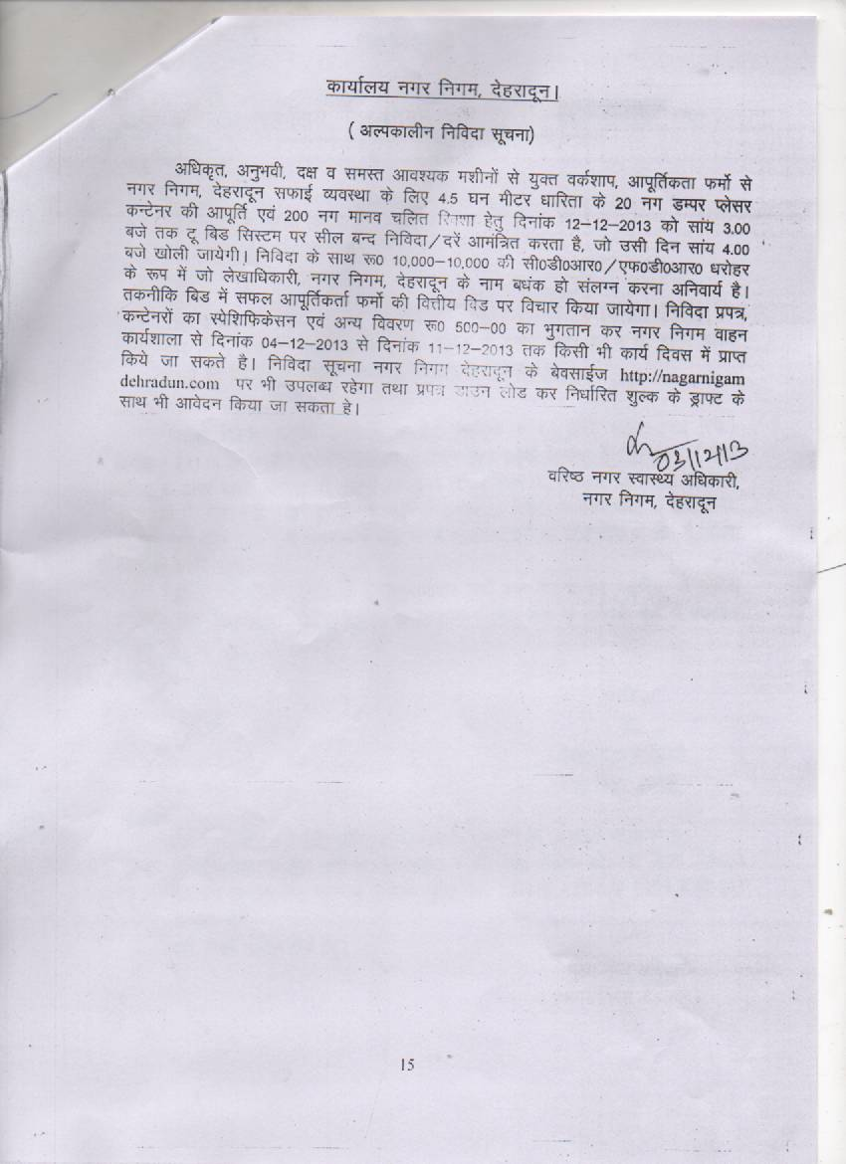
Sr.no……….

Tender Documents

For The

Supply and maintenance

Of

4.5 cubic meter Dumper Placer Container & 4.5 cubic meter Tractor Container and Three wheeler man operated rickshaws

Cost Of The Tender Documents Rs. 500.00

Nagar Nigam, Dehradun

NAGAR NIGAM, DEHRADUN
INDEX FOR THE TENDER DOCUMENT
Supply and maintenance
Of
4.5 cubic meter Dumper Placer Container & 4.5 cubic meter Tractor Container

SR DETAILS PAGE NO.
NO.
1 Particulars of the tenders 3

2 Technical and financial bid requirements 4

3 Two Envelopes to be used for Financial 5
And Technical Bid; Details

4 Time frame for Supply and maintenance 6

5 Payments Schedule/warranty other condition 7

6 Instruction, term and conditions to the
Bidder, regarding earnest money, security
Money, Financial Status and credibility 8-9

7 Schedule ‘B’ for quoting rates for
Fabrication and supply 10

8 Technical Specifications of Dumper Placer Container 11

PARTICULARS OF TENDERS
1. Particulars of work Supply and maintenance of 4.5 cubic
Dumper Placer Container & 4.5
cubic meter Tractor Container

2. Period of supply within 30 days from the date of supply order

3. Cost of tender form Rs 500.00 cash or DD in
The name of Senior Municipal Health Officer, Nagar Nigam Dehradun

4. Earnest money 2% of tender awarded cost in the form of FDR/CDR/Bank Guarantee

5 Sale of Tender forms 04-12-13 to 12-12-13

6 Date and Time of Submission of tender 13-12-13 at 3 pm

7. Date and time of opening of Technical Bid 13-12-13 at 4 pm

9 place of opening of tender Municipal Health Officer Room, Nagar Nigam, Dehradun.

10 Period of validity of tender 12 months

11 Name and address of the firm
to whom tender documents is issued ----------------------------------- ------------------------------------------

Senior Municipal Health officer
Nagar Nigam, Dehradun

TECHNICAL BID AND FINANCIAL BID REQUIREMENTS
TENDER NOTICE FOR FABRICATION AND SUPPLY OF
Fabrication and Supply
Of
4.5 cubic meter Dumper Placer Container & 4.5 cubic meter Tractor Container

IN NAGAR NIGAM DEHRADUN

Tenders are invited from the reputed, capable, efficient and experienced suppliers/ workshops/ firms /companies for the supply and fabrication of 4.5 cubic meter Dumper Placer Container with one year warranty against the manufacturing defects.
The tender should give a detailed technical proposal to carry out the above job as per the technical bid. The financial shall be opened only after the approval of technical bid from the Nagar Nigam, Dehradun.
All the bidders shall be examined and evaluated first technically and as per the past supply experience and other relevant factors. Detail to be provided with the technical bid.

1 Supply and maintenance (for one year warranty) of Dumper Placer Container
During the last two years
1.1 List of ULB, departments and places
1.2 Total no of Dumper Placer supplied
1.3 Performance certificates copies and order copies issued by the competent authorities.
1.4 The bidder must have supplied at least 30 Dumper Placer Container of any capacity during the last one years.
1.5 Copy of letter showing letters of showing satisfaction and any other relevant information.
1.6 Turn over must be not less than 10 lakhs for the current year.
1.7 Required earnest money as per 2% of the quoted rates.

2 Detail of staff with their technical qualification and workshop details
Detail of staff and their qualification.
  - Place and location of workshop.
  - Copy of the registration with the industrial department.
  - Copy of sanctioning of the power connection taken from the power corporation of the state
  - At workshop types of machines and their nos.
  - O/M experience
  - Detail of R&D section of the company if any.
  - Tenderer must have valid registration certificate for manufacturing from SSI
- Income tax, sales tax department registration and SSI department registration of the company.

TWO ENVELOPS TO BE USED FOR TECHNICAL AND FINANCIAL BID AND MODE OF SUBMISSION.

Separate sealed envelops should be used for technical bid Envelop’A’ and Financial bid Envelop ‘B’ and both the envelops A and B are to be kept in a bigger envelop which is to be sealed at the time of submission. Open envelops are liable to be cancelled. The envelops must be addressed to Municipal Health officer, Nager Nigam , Dehradun.

Tender can be submitted to the Nagar Nigam Dehradun at the office of Workshop Incharge / Health Officer, Nager Nigam , Dehradun.Before the stipulated date and time.Tender can be also be submitted thorugh registered post or by the hand to the tender box placed at office of Workshop Incharge/ Health Officer, Nagger Nigam , Dehradun before the stipulated date and time. After the stipulated date and time the tender will not be considered. Delay due to postal services will be the liability of the bidder.

Only the rates or financial bid of such bidder shall be opened or considered those who will qualify in the technical bid.

Very Important:
Due to the non compliance of the above tender proposal will be summarily rejected.

TIME FRAME FOR THE SUPPLYOF TRACTOR CONTAINER CARRIER OF 4.5 CUBIC METER DUMPER PLACER CONTAINER& 4.5 TRACTOR CONTAINERS

1 After getting the information from Nagar Nigam to the lowest bidder required stamp paper and other formalities for signing contract are to be completed in all respect within 2 days by the lowest / qualified bidder.

2 The required supply of equipment is to be delivered as per the supply order at the designated place/ store of Nagar Nigam Dehradun and should be completed within next 25 days from the date of order given by Nagar Nigam Dehradun.

3 After completion of the supply the officer in charge will check the newly supplied equipment and after the satisfaction certificates to be issued if required.

4 For time over run per day penalty may be imposed which may be rupees 100 per day per equipment after expiry of the stipulated time for supply. Time over run may be exempted for the genuine reasons which are to be forwarded by the office in charge and that may not be considered / exepted by Mukhya Nagar Adhikari

PAYMENT SCHEDULE

1 After proper supply and inspection of the equipment the payment may be released after recommendation of the technical report of the officer in charge/ committee prescribed for that work.

2 At the time of payment as per the standard practice of the government department a security of 2 % may be withheld unto a maximum of six months. This may be released after six months of proper functioning of the equipment after adjusting the earnest money deposit in shape of Bank Guarantee/FDR/CDR/NSC/DD pledged in the name of Up Nagar Adhikari. Nagar Nigam Dehradun.

MAINTENANCE/WARRANTY

1 There will be a comprehensive maintenance warranty of 12 months from the date of supply
2 Under the definition of Warranty, The maintenance of the equipment the smallest fault is considered to be covered except the accidental damage.
3 Local availability of educated technical man power and spares for necessary preventive and Corrective maintenance break down services etc within 24 hrs will have to be insured by the Firm during the warranty period.

OTHER CONDITIONS FOR SUPPLY

1 During the fabrication the authorized person from Nagar Nigam Dehradun may inspect the Workshop/ fabrication place for getting the clear progress of fabrication and for insuring the quality of product.

2 Nagar Nigam Dehradun has the right to reduce or increase the requirement of the above Supply nos.

INSTRUCTIONS TO THE BIDDER AND OTHER TERMS AND CONDITIONS

- EARNEST MONEY AND THE VALIDITY OF THE TENDER
1 Each tender shall be accompanied by the requisite earnest money in the form of Bank Guarantee/FDR/CDR/DD/NSC in favor of Up Nagar Adhikari,. Nagar Nigam Dehradun.

2 Without earnest money tender is liable to be disqualified

3 Earnest money shall be returned back after the supply of the equipment at the store at Nagar Nigam Defraud or may be adjusted in the security deposit if desired by the bidder.

4 Validity of the the offer must be 12 months from the date of submission of tender.

- CASTING AND OPENING OF THE TENDER

1 The tender must be newly written, preferably typed every page of the tender document should be signed with seal the rate must be quoted in words also
2 Nagar Nigam holds the right to reject any or all the tenders or except any tender after Analyzing technical bid and financial bid in total or in part of work may be decided among various tenders without assigning any reason.
3 Nagar Nigam has right to change the time of opening of technical and financial bid at any time
4 All the information must be in English and figures must be in MKS system.
5 Tender must contain the name, address, place of business, land and mobile nos, email, Website .the representative must bring the authorization letter from the tendered having representative attested signatures.
6 Any approach / undue pressure by any firm shall render the tender liable to be rejected.
7 Any tender if deviates from the given terms and conditions and technical specifications Specified in the tender shall liable to be rejected
8. On acceptance of the tender, the tenderer will be required to execute an agreement which will be treated as contract for the tendered work on non judicial stamp papers of required value, as per GO’s provision.
9 If tenderer fails to sign the agreement within the stipulated period of 2 days from the date of the confirmation of the lowest bidder its earnest money shall be forfeited by the department.

10 The tendering firm/ company should be registered under the relevant statues by the relevant competent authority. The firm must attach copy of the registration certificates

11 The tender price will be inclusive of all taxes and duties, i.e, central/ state and local taxes as F.O.R Dehradun

FINANCIAL STATUS

1 Bank guarantee shall be issued by the nationalized bank and duly signed and stamped.
2 Income tax returns certificates of at least last 1 years
3 Liquid fund availability along with certificate signed by C.A. Balance sheet for last one year

CREDIABILTY
The bidder must give an certificate that he has not been or is not blacklisted from any government or semi govt. department.

Senior Municipal Health officer
Nagar Nigam, Dehradun

NAGAR NIGAM DEHRADUN
SCHEDULE ‘B’

NAME OF THE WORK Supply and Maintenance of 4.5 cubic
meter Dumper Placer Container & Tractor Container 4.5 Cubic meter

S.NO. | DESCRIPTION | QTY | RATE  IN Rs. Per No. | AMOUNT  IN Rs.
1 | Fabrication and Supply of 4-5 cubic metre capacity, DP (Dumper Placer) garbage beans complete in all respect FOR Dehradun as per the existing DP of Nagar Nigam Dehradun of standard size given below. | 10
2 | Fabrication and Supply of 4-5 cubic metre capacity, Tractor Container garbage beans complete in all respect FOR Dehradun as per the existing TC of Nagar Nigam Dehradun of standard size given below. | 10

Municipal Health officer
Nagar Nigam Dehradun

Date:

Place: Signature of Tenderer

Detailed Technical Specification of Dumper Placer Container Of 4.5 Cubic Meter Capacity

- Size must be standard as per the given drawing Length-2670 mm, Internal Width-1500mm, Maximum Width-1600 mm, Maximum Height-1500 mm.
2. Base-10 Gauge, Side and Slope-10 Gauge, Top-14 Gauge for joint angle ISA 35x35x5 at borders/Edges, four side channel at base, side, top, door mounting for support/stenghtening IMC 75x40x40 mm. (Standard make and section 5-7 mm. and transverse support IMC 75x40x40) For window border 25x25x5.
3. Four Windows of size 1000 mmx400 mm. 16 Gauge.
4. One Door 12 Gauge.
5. Kabze/Latches of 9 cubic meter Twin Dumper Placer type 4 numbers in doors (50mm x25 mm Flat) and three for windows (100mmx50mmx3mm)
6. Handle and supports for Door and windows not less than 12 mm.

Detailed Technical Specification of Tractor Container 4.5 Cubic Meter Capacity

1. Size Length 2500 MM
Width 1500 MM
Height 1500 MM
2. Base 3MM side and slope-2.5MM Top 2MM
3. Four Window 1.6 MM each
4. One door 1.6 MM
5. Latches of DCM Toyta type 4+4 number in door and three for windows
6. Handle for door and windows

Senior Municipal Health officer
Nagar Nigam Dehradun
FkzhOghyj ekuo pkfyr fjD’ks dk Lisf’kfQds’ku

S.NO. | DESCRIPTION | QTY | RATE  IN Rs. Per No. | AMOUNT  IN Rs.
1. | FkzhOghyj ekuo pkfyr fjD’kk yksgk ckWMh e; 06 fMCcs {kerk 20 yh0 lfgr  Lisf’kfQds’ku%& psfpl uhye dEiuh] FkzhOghyj ihNs ds Vk;j Bksl jcM] okys] gSoh fje eksVh yksgk ikbZi] ckMh dh ryh 14 xst yksgs ds pknj] lkbZM dh pknj 16 xst] okWMh lkbZt 01 ehVj yEch] 30 bap pkSM+h] 16 bap ÅWpkbZ] ckWMh dk ,Uxy 1 bap ] /kwjk 1-5 bap] xksy] Mkyk [kqyus okyk] ?kUVh@Hkksiw gSfUMy lfgr] jax] jksxu ,oa fy[kkbZ lfgr dEiyhVA | 200

Senior Municipal Health officer
Nagar Nigam Dehradun

